“Universal Truth.”

1. Conscience of the higher Aliens. (Aliens are also under the rule of the God Jesus.)
2. How the pride of Jewish nationalism turns into the wildness.
3. “What is social?” by Harvey Cox.
4. How can you live with the religion of "Do not judge?"
5. The birth of wild Jewish nationalism.
6. Manipulating pretexts for missionary work to Gentiles.
7. Jews are the biggest victims of the man-made religion "Judaism."
8. Netanyahu Trump Xi Jinping's Cigarette Smoke Power & power of “Conscience.”

9. Why is an woman “the sinner of the original sin” in the Bible ?
(Unprofitable loss of female birth made sinners. (Groundless Christian Sexism)
10. Why is a man made of mud ?
11. Religious ecstasy in the Hebrew Bible "book of Job."
12. How densely are "holy scriptures" polluted for opportunistic nationalism ?

13. What a notorious gold digger the Korean first lady "Julie" is. # 1
Samsung arranged the gold digger and the chief prosecutors. # 2
Did they throw a wild party and film it from behind ? # 3
14. A Japanese imperialist group that inherits the insane "Kamikaze" spirit.

15. “Street Opportunism," but a virtue of the national heroes in tiny nations in the Near East.
16. True Christian knowledge and wisdom can cure "everything" in the world.
(Who can practice "Love your enemy," an absurd Bible verse?)

17. Was the female President having an affair when 300 teenagers drowned ?
18. 159 were senselessly crushed to death, and 195 were injured in Etaewon, Seoul.

19. "Balance of body" is the key to the seniors' health.

Recipients who read this file “lord.docx,” please send the subscription fee of $20 per person
to : Kook-Min bank account # 743201 04 058620 Sang wook Lee, swift code CZNBKRSE
South Korea. If you are worried about overseas remittance fees, you can save on remittance fees by pooling money with colleagues from one university and sending it together.
This “lord.docx” file will be continuously upgraded in the future to contain all my essays, and once you pay the fee, you have the right to download the future upgraded versions forever free.

< The following essays will be included in my next “lord.docx” file in December. >

2, Jesus is neither the son of God, nor of Jehovah.
3, Paper God "Jehovah" never existed.
4, Jesus' Christianity is ten times simpler than you worry.

7, Why are humans addicted to "emotional madness, and religious fanaticism ?"
9, Only correct Christianity can stop world disorder.
12, How the pride of Jewish nationalism turns into the madness.
13, The birth of fanatical Jewish violence.

16, "Prophetic imagination," which is admired as the absolute truth by the fanatics.
19, Conservative Christianity, Judaism, Islam should be banned by law.
20, Forces of "Conscience" that shall stop international criminal violence.
21, Netanyahu Trump Xi Jinping's Cigarette Smoke Power & “Conscience.”
22, Modern society is being dominated by vicious, trash elites at the level of gangsters.
23, Trump is "a badly cooked damned human beast."
25, Christianity keeps producing evil elites in Korea.
27, South and North Korea have been being ruled by devils.
28, Seoul Law School rescued a definite criminal made him president.
(Lawyers' tyranny of one mammoth law school in south Korea.)

30, Why not have Korean people resist the lunatic regime they used to?
31, Christianity is producing evil elites in Korea and around the world.
32, Why did the math professor go to the judge with a crossbow?
37, Korea is a country ruled by devils.

1, Conscience of the higher Aliens.

< Robert B. Coote, a student of G. E. Wright and F M Cross, comments on this essay; "A grand, hopeful conceiving of monotheism, the one God in Jesus, throughout the universe. You express both candor about religion and trust that better will be possible." >

Higher animals on other planets whose intellectual abilities are higher than our Homo sapiens on earth are undoubtedly possible in the universe, whose size is not only bigger than we think but also bigger than we can think.

Humanity evolved reason and established utilitarian ethics, the core of which is "conscience."
Conscience is the truth itself, the integration of the three ideals of "truth, goodness, and beauty."
Conscience is the technical synapse of the reasons, which can be called the "technicality, or justice of reason," that maximizes the satisfactions of maximum elements and members.

Higher animals can think of and possess higher conscience, which can produce the better solutions in all social sciences and human sciences i.e. laws, politics, economics, theology, Art and culture etc. etc., simply because higher conscience (higher technology of the reason) can analyze, organize the better composites, and run the better community world. Higher aliens on other planets whose intellectual abilities are higher than humans on earth must have acquired themselves with better "ethics of utilitarianism," whose essential content, the conscience, must be higher than ours.

The progress of the culture and civilization is something mutual, cooperative, and general, which triggers, helps, cooperates, challenges and evokes, competes, and copies each other in a synthetically dialectical process.
Yes, it is generally obvious that "higher aliens" must have "better quality and more sum of consciences" than we, which can stimulate, provoke, and harmonize to produce many better wonderful things in all areas, not only the science of weapons" in science fiction movies like "Star Trek."

More developed countries generally show off better social products of better arts, better education of better educators, better politics, better theology, better social science, better human science, better jurisdiction, better intellectuals, and better government activities in even better ways. "Social Conscience" is the primary core content that decides the future success or failure of all intellectual activities, since it draws the fundamental baselines of all intellectual activities.

The supremacy of western culture and civilization stems from the supreme quality conscience of Christianity, which has inside devotion, cooperation, charity, humbleness, integrity, and wisdom, very clearly, which had existed rarely in oriental culture except for some sages' shy literature.

Christian conscience has both the virtues and the efficiencies of human activities, spiritual and physical, which are the core fuels of a community world that can go forward by itself.
It is very rarely possible to imagine the success of "the French Revolution" without the theoretical buttress of "the social contract" of J. J. Rousseau, who declared that everything of his ideas borrowed from the teachings of Jesus.
The value of John Locke, who initiated "separations of the power" in the process of the Democracy of England, is absolute and incomparable, whose ideas came from Jesus' teachings.

It is hardly possible to expect just the supremacy of science of weapons and flying saucers without having the assistance of the supremacy of social and human sciences (democracy) in general, since the supremacy of natural science could be made only by well-maintained education and a group of well-educated scientists who have been grown up in mature society, which must rely upon a good amount of social assets that have survived in long term survival combats of trials and errors.

Lee Kwan-Yew (late former prime minister of Singapore) said that China can neither rule the world nor compete with the U.S. and the European Union at all, since the democracy of China is quite far behind the U.S. and the E.U.
One hypothesis of the craters of Mars explains that Mars had perished by itself by nuclear civil war. Corruptions, bribery, embezzlement, cheating and deceptions, and conspiracies of the government officers and politicians of eastern countries are very usual and chronic, like crimes of hierarchy.

Politicians take it for granted that they are the ruling elites even in democratic systems.
Chinese politicians do not hesitate to deny "three separations of power" in public.
Higher aliens must suffer from quite many painful procedures in their progress of building up and managing such mature societies, as well as we humans have suffered quite a grave amount to pay to reach contemporary brilliant accomplishments of culture and civilization for many millennia.

It seems quite likely that they must have had civil wars, world wars, bloody revolutions of class and race conflicts, slavery and hierarchy, brutal nationalism and sexism, etc., etc. alike.
Let me suggest a hypothesis that higher civilizations must accompany the higher level of democracy of conscience and well-balanced socialization of the societies.
Higher aliens and higher civilians must have a better level of personal conscience too, since they are the results of better social agreements of better social conscience.

How can I prove this hypothesis that higher aliens must be good guys, not bad ones?
There are quite a lot of witnesses and evidence of flying saucers and higher aliens in the history of Homo sapiens; however, there is no witness or record that they have attacked Homo sapiens on earth with their mightier weapons of superior science.

I conjecture that they have had more conscience than we, good enough not to attack and kill, presumably the same attitudes that mature intellects have.
NASA shall not order to attack and kill aliens of other planets only because we humans have superior weapons than they have, since Americans are well educated, mature citizens, while it is not sure of the communist regimes of Russia and China, who had shot down civil aircraft of 269 innocent passengers in 1983 and persecuted Uyghurs just for avarice.
European countries that took advantage of occupying colonial countries as cruel bullies, and many savage countries whose massacre background could not be free from the accusations.

If there were any higher aliens on other planets than Homo sapiens, it might not be a hasty judgment that they are the ones who could have more graces in a longer period than we on earth, which does make sense when Jesus turns to be the universal God-being.
Christianity is the sole religion in mankind's history that executed Jesus not only showed off again after the death but also converted one of the grisliest opponents of humans thoroughly enough to be the most complete "spokesman," apostle Paul.

It is also very likely that such a miracle appearance of interception and interference of Jesus has continued and off as the universal God being, the patron of Homo sapiens. There is no single misfire accident of nuclear weapons reported out of thousands of them, when just one misuse of them might create a global unrecoverable catastrophe.
We have been safe from quite many possible collisions of asteroids and meteors as well.
The distance from the sun and the earth keeps 149,597,870,696 meters, whose balance has kept the life of Homo sapiens safe and prosperous.

( Acts chapter 9:1-5 )

1 Meanwhile Saul, still breathing threats and murder against the disciples of the Lord, went
to the high priest 2 and asked him for letters to the synagogues at Damascus, so that if he
found any who belonged to the Way, men or women, he might bring them bound to Jerusalem.
3 Now as he was going along and approaching Damascus, suddenly a light from heaven flashed around him. 4 He fell to the ground and heard a voice saying to him, "Saul, Saul, why do you persecute me?"
5 He asked, "Who are you, Lord?" The reply came, "I am Jesus, whom you are persecuting."

The above paragraph of the Bible "Acts" is regarded as a "definite fact" even by most non-Christian historians, since Christianity cannot be explained by this very vivid miracle happening, whose dramatic ups and downs of the following events are the histories of all we mankind.
What kind of religion aliens of higher conscience than homo-sapiens could have when Jesus is the most possible God-being in mankind history with his wonderful teachings of divine conscience, passionate devotion, and the performance of transferring death to life?

Higher aliens could worship Jesus too, as Homo sapiens does with different sets of scriptures and circumstances, if they were only the same kinds of same higher animals who could only be envious of God's ability of transferring death to life freely. Jesus' physical performance of transferring death to life cannot be imagined, which other higher aliens could copy or imitate.
A very old preacher who had been through quite many hardships from the colonial period of Korea, ruthless cruel dictators, and shortage of food and livings, however, preached more than any Christian preacher in the world.
He prayed so hard to see the figure of Jesus to make sure if Jesus was someone really worth risking his life.
He, a close friend of mine who never needed to tell a lie or exaggerate, told me that he had seen very clearly that Jesus rules the universe while in his prayer or in sleep.

Jesus seems good enough to be the God of aliens too so far, since his teachings and passionate devotion are spotlessly perfect and sincere that none of us could argue with, except for scriptural forgeries, which had been made up and added in early church history when the Bible writers had been faced with different hardships to excuse for.

The parts of "son of God" as the heir of Judaism God Jehovah and his racial sayings had been fabricated firstly, the disciples of Jesus were Jews who had been strictly limited in the customary regulations of "anti-Gentile restrictions."

Secondly, the writers had to make Jesus not only friendly with Judaism but also totally subjective to Judaism to get along with ancient Israelites, who tried to wipe off all remained Judean Christians.
There was a move to wipe off all remained Christians after the execution of Jesus, led by frantic priestly leaders of Judaism in exact the same way of "holy war." "Holy war" is a systematic massacre of the opponents led by priestly elites.

Very ironically, the most frantic leader of Judaism became the most powerful leader of Christianity, who not only completed the theology of early Christianity but also launched to preach to Gentiles, apostle Paul.
Writers of Gospel Matthew and Gospel Luke had to set up the theological defense rampart desperately, which appealed to their opponents, frantic Judaism believers, "We are the faithful Israelites too in the same boat," which culminated in strategic "Gospels of the Jews."

Complicated historical situations in ancient times had made Christianity "one monstrous religion," which keeps justice and injustice, truth and untruth, and facts and fictions in one mysterious capsule, the holy Bible, which has completed "one total wealth of hypocrisies" of western Christian culture, in a word shameless "Christian Imperialism."

Western Christian culture is full of bizarre selfishness, cruel hypocrites, and holy foolishness of self-contradictions even without a gram of guilty conscience, which are the clear outcomes of failure of "misunderstanding of God Jesus."

The definite core concept of Jesus' teaching is "global socialism and its ethics" on earth, whose wider concept might be called "the Universal Utilitarianism," whose goal is the maximum satisfactions and happiness of all living members in the Universe.
However, the forefronts of opposing the global socialism of equal rights of the nations and civilians are the groups of people who are affiliated with Christianity and Judaism, who never want to share the pies of "the selected people of God."

These elites have taken advantage of unfair shares of the pies as holy gifts from God for quite a long time as the privileges, which is a very subjective judgement.

Crime level deception and clever opportunism of Jacob in the Old Testament, who deceived his father to intercept the inheritance of his brother, exploitation of the bizarre rulers like King David and Solomon, and irrational holy achievements of Moses and Joshua are the fruitful choice models of Christian elites in the western world.

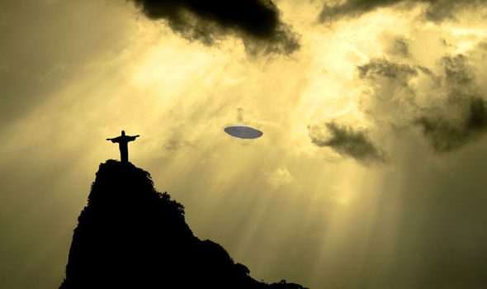

2. How the pride of Jewish nationalism turns into the wildness.

The emotional nature of religion is to stimulate fanaticism and induce ecstasy, which often interferes with rational judgment and incites emotions, leading to violence.
In Israel, a very small country, the priests and scribes injected many exaggerations and speculations from the beginning period of making up the Old Testament in order to relieve their complexes.
The first purpose of a priest is to make a living, not to record facts and reveal the truth especially in ancient time. Priests make a living by providing magic or fortunetelling to the elite, not a profession that explores and ponders the truth like philosophers.
The priest group of David were a group similar to civil servants who only had the ability to write and read and performed administrative functions and related religious affairs in ancient society.
It can be assumed that the priest group of David's warlord group active in the mountainous regions of Israel, a small state of the size of Vermont, is a half-civil servant, half-religious group with the ability to read and write Hebrew letters.
It is very dangerous to believe that David's party, which founded the nation of Israel, which many modern theologians judge to be a group of bandits like, and the group of priests living around David's regime, are a perfectly righteous group righteous to God.
The reason why the western world long ago defined the Bible as the absolute truth of God was because they did not have the ability to discern the many contradictions and questions that appeared in the Bible during the Dark Ages of the Middle Ages, and insisted on using it as a shield to justify the dictatorial power that was formed on the base of bizarre understanding of the Bible.
It is a very natural phenomenon that gentiles worship Jehovah, the God of Judaism, with the ideology of stubborn conservative Christianity, and that Jews, in a trend of blindly gentiles' obeying their own Judaism, came to obey more blindly than gentiles since they are the orginal writers and owners of the scriptures.
Jews must think that Gentiles believe in our nationalistic Old Testament with such zeal, so can't we help but think that we should even more recite and believe in it as absolute truth and wage a holy war in ever more cruel ways?
Looking at Jesus, whom people all over the world believe in at the cost of their lives as “Lord,” and the many Christians and churches, the Jews who believe that Jesus is the Son of Jehovah and that Judaism is the origin of Christianity may be wondering if their national pride could reach the point of hallucination.
This may be a sort of natural phenomenon.
If you are a conservative Christian or a Jew who climbs up on a high cliff and looks at the countless stars praising the name of Jehovah floating in the sky, and the colorful moon and starlight fluttering in the sea praising Jehovah, you will slaughter everything that opposes Jehovah’s commands of the Old Testament including your son like Abraham.
Christian Philosopher Kierkegaard died at the young age of 42 while seriously contemplating this kind of bizarre issue of Christianity. He famously confessed that he could respect Abraham, who tried to sacrifice his son Isaac to Jehovah, but he could not become Abraham. "I respect Abraham, but I cannot become a Abraham."
Who would dare to disobey the holy command of the holy Jehovah in the holy scriptures, who killed even his own beloved son, Jesus, to give eternal holy salvation to all mankind ?
This is the duality of the poison contained in the sweet pie called Christianity, and the problem of modern theology is that such Christian sweet pies have no choice but to be distributed in large quantities at McDonald's.
Although we cannot justify the insane cruelty shown by the Jews by calling it a holy war, it is true that we cannot
blame their cruel nature solely on their own fault. (But also its the fault us gentles, too.)
15 you shall put the inhabitants of that town to the sword, utterly destroying it and everything in it?
—even putting its livestock to the sword. 16 All of its spoil you shall gather into its public square;
then burn the town and all its spoil with fire, as a whole burnt offering to the Lord your God. It
shall remain a perpetual ruin, never to be rebuilt. - Deuteronomy chapter 13: verse 15, 16

They may simply be imitating the violence created by Westerners' errors in judgment in the Christian scriptures.
For that reason, humanity should no longer stand by and ignore groups that arbitrarily and fanatically interpret and abuse the Bible, whether they are Gentiles or Jews, just for the sweet reason of “religious freedom.”
In today's era of rampant violence, many Bible scholars are extremely reluctant to have their addresses made public for fear of threats of violence from fanatical conservative Christians and Jews.
What is the difference between you being massacred in a gas chamber by a quarter Jewish Adolf Hitler, and the massacre of Gaza residents now?
We must realize that this is a result of faulty judgment, and abandon the absurd racial nationalism that some frantic Jews insist on as the absolute truth of the Old Testament.
Even within Israel, the conflict between conservative fanatics and citizens who respect common sense is a chronic religious conflict that is difficult to resolve.

Israelis continue to protest judicial overhaul for 32nd straight week

20 journalists were killed by Israeli soldiers, shot them through gaps in their bulletproof vests claimed by Palestinian Prosecutor General.



"At least 274 Palestinians, including dozens of children, were killed, and hundreds more were wounded, in the Israeli raid that rescued four hostages held by Hamas."


Kierkegaard, who had to die at the young age of 42 after repeatedly worrying about the bizarre conundrums of the Christianity.
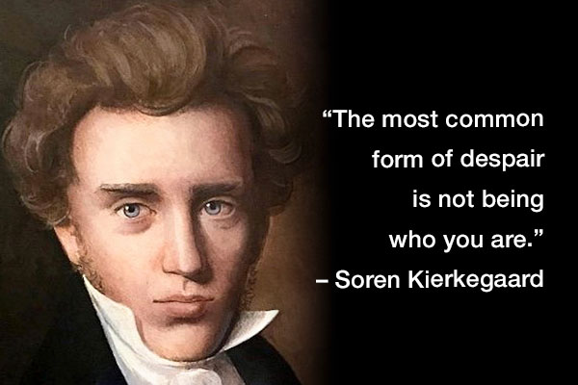
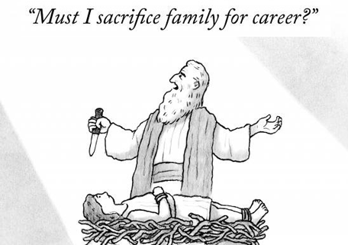

3. "What is social ?" by Harvey Cox.

Human live Humans live within the definition of a "social animal," but in reality, that society is filled with things like "religious oppression and violence," "pollution of nationalism and the deception of mad politicians," and even intellectuals in advanced countries with a fancy democracy live each day under the threat of extreme opportunistic violence to the point that they are reluctant to reveal their beliefs and convictions.

Harvey Cox extended the meaning of "social" to "universal," and now that Judaism and Islam have been proven to be nothing more than regional superstitions and conservative Christianity has been proven to be a forced allegorical theory, the soul of humanity must prepare for its voyage to the infinite universal world.

Scholars have their own individual and professional world of pure souls, where they analyze and conclude pure ideas within their league. The "truth" that professional scholars derive from the analysis and combination of pure and essential theories is in fact a result of absolute power.

In the pure conversations of human souls, the common goals that humanity should pursue forever, such as "love," "cooperation," "conscience," "charity," "dedication,” and "fortune"
have almost all disappeared at some point, and the world has become a cruel place where only violent ideologies, such as "nationalism," "capitalism," and "commercialism," run rampant.

This is not because Jesus Christ, who led human civilization, died, but because Christian theology, which has led human civilization, wandered without having an ability to get to the point of being understood.

I have no doubt that if humanity correctly understands Jesus and aligns its signals with Him, Jesus' absolute power, which best suits the perfection of God, will solve all the problems of the human world.
If it is possible that higher aliens exist millions of years before us Homo sapiens, what could the incredible technological prowess of a God who is even much more advanced than them not be able to do?

If you ask me whether I am not afraid of attacks from the evildoers and their supporters whom I condemn, I will reply and ask why, in a universe governed by the law of Jesus, should I be afraid of attacks from a few such evil men?
I am one of the theologians who understands the Bible most accurately and as a believer who is fully capable of interacting with the order of heaven, I really have no fear.

As a civilian who has analyzed and resisted the corruption and crimes of Korean politicians and government most deeply, I have been under surveillance by many Korean government intelligence agents for a long time,
and even the letters in the email I am writing now are recorded by intelligence agents.
I have been through a period of severe training under God for thirty years, to the point where He let me know what kind of group was watching me or hating me and what attitude they were taking toward me, and He also mentally confirmed to me the limits of how their attacks could ever harm me.

To the extent that I am confident in my theology, I am confident that the Lord's church can establish proper order in this world that has become a mess of violence, pollution, and disorder.
I am confident that I will confirm the miracles I have experienced, the correct knowledge of the Bible, and the miracles of God to all mankind through the Lord's church.

I curse the world's evildoers, Trump, Netanyahu, Putin, Xi Jinping, and Myanmar warlords, and I pray that they will be destroyed soon in the name of the sole God, Jesus Christ.
We fight for the destruction of the wicked; therefore, we Christians exist !

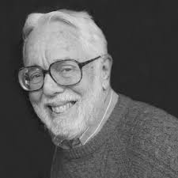

4. How can you live with "Do not judge?"

Among my acquaintances, there was a person who received a score that would allow him to enter the Law School, but he went to business school because his mother said that the Bible says, "Do not judge" and that he could not enter a department where some conservative Christians would condemn him.

The Bible justifies the absurd and groundless stubbornness of the local law teachers by comparing them to God or Jesus, and the history of mankind has been oppressed for a long time with stubbornness and violence. Now, mankind must become mature and free itself from such stubbornness and violence.

The Gospel of Matthew was written shortly after the publication of the first Bible, the Gospel of Mark. The Gospel of Matthew was written to fill a gap felt by Jewish Christians who felt threatened by the Gospel of Mark, which did not contain Jewish laws of "anti-Gentile restriction" that required Christians to be stoned to death if they did not discriminate against Gentiles. Even if you were not Matthew, the author of this gospel, you would have put yourself in Matthew's shoes and created the Gospel of Matthew to avert the murderous violence of the Jews against Jewish Christians.

The genealogy of Jesus was fabricated at the very beginning chapter of the Gospel of Matthew.
This kind of ceremonial genealogy of Judaism is something that most Jews would have, but its
contents are a means to brainwash vague nationalism in the citizens of ancient society who did not have the discernment of knowledge, such as Uncle Sam gave birth to President Washington, Washington gave birth to Thomas Jefferson, Thomas Jefferson gave birth to Abraham Lincoln, and then gave birth to Roosevelt.
https://suban.com/genealogy.htm (Luke copied what Matthew created).

The reason why fortune tellers, priests and the Old Testament scribes who wrote the Hebrew Bible are such a vicious group is because they force innocent civilians to live like "slaves" tied to their religious commercialism to support their livelihood.
They are a vicious group that has been brazenly repeating the act of manipulating and exaggerating facts to increase their evil purposes and interests, all the while using the name of Jehovah as the almighty God.
Even in modern Korea, shamans commit fraudulent crimes by promising misfortune to families if you do not follow their spells, but some stupid judges often find them not guilty on the grounds of "freedom of religion."

There are many third-rate frauds in Christianity and Judaism like Michael Drosnin, who sold a ton of garbage called "the Bible Code," claiming that mysterious prophecies were hidden in the Hebrew Bible, which was stained with all sorts of inexpensive exaggerations, lies, and editing.
I believe that Matthew, the tax collector, ordered the theme and plot and that it was a local guru like Pharisee who actually wrote the Gospel of Matthew.
Most of the content that Matthew added to the original Gospel of Mark as Jesus' teachings is because it contained a lot of plausible religious wisdom that the Pharisees used to sell Judaism.
The content of the Gospel of Matthew from chapters 4 to 7, which is not in the original Gospel of Mark, can be seen as Matthew's propagation of the content corresponding to the local law teachers, Pharisees, or the everyday wisdom of Judaism through the mouth of Jesus.

We can see that Matthew's specialty, a special beef steak, has been topped with three pizza toppings.
You are not only theologians and historians but also legal scholars, so I trust you will make an
objective judgment in the process of collecting fingerprints of the clever suspects who entangled complex cases.

When lawyers advertise their business, they tell you that if you have a car accident or a complicated criminal case, you should call their office immediately and seek legal advice without being swamped with unfavorable evidence or witnesses.
Matthew uses a similar tactic to advise people not to judge the complex political and religious conformity of ancient Israelite society but to knock on his office door.
https://suban.com/judgenot.htm
https://suban.com/seek.htm

If there were telephones in ancient Israel, wouldn't the author of the Gospel of Matthew have included his own phone number at the end?

If then the occupation of the author of the Gospel of Matthew was a Pharisee, different from the
Sadducees who governed the religious laws of Israel in the temple, how can the passages in the Gospel of Matthew criticizing the Pharisees be explained?

I was a student at a Jewish studies school 30 years ago, taking a class taught by David Winston, a renowned rabbi scholar, and one of the most shocking passages I ever heard was, "A Pharisee criticizes another Pharisee."

It is very likely that the Pharisee who wrote the Gospel of Matthew, hired by Matthew, criticized another group of Pharisees, and class conflicts within the Pharisees were quite possible.

The clashes between the various sects that interpret the Hebrew Bible, which was forcibly created for the purpose of merging politics and religion, are an inevitable clash of gunfire. Just as politicians criticize politicians and clergy criticize clergy, it is perhaps only natural that the Pharisees, a group of local law teachers, clash and criticize each other due to differences in judgment and class status.
https://suban.com/scribepharisee.htm
https://4gtmovement.com/seven-kinds-of-pharisees

Jesus never said, "Do not judge." It is only a slice of pie of commercial Judaism coated in Jesus’ name.
How about humans who have regained our mature judgment call the works of the authors of the Gospels, who are suspected of being absurd Pharisees alike who added three pizza toppings on top of a beef steak like in the Gospel of Matthew, "Holy counterfeits?"
When you acquire the ability to discern the counterfeit money from the vaults of gold that the Jews are so proud of, you will be able to rescue the real and true Jesus who is locked up in their vaults.

Holiness is an object of awe for the public, and even looking at it with the eyes of suspicion is considered blasphemous. Due to this one-sided violence of holiness, mankind has regarded obedience in eating bizarre beef steaks with three pizza toppings without complaining for 2,000 years as a religious virtue.
The Bible has been a fascinating fun subject of study for keen Bible scholars with a detective's eye, but shouldn't all mankind now agree that the Bible is a truly fascinating "Fun book?"

As you discover more fun in the Bible, you will really discover the true fun of life !

"Islam, Judaism, Buddhism and conservative Christianity" are not religion, but only man-made superstition !

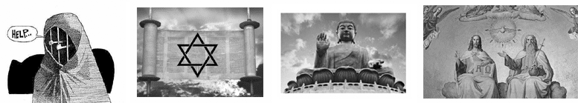

5. The birth of wild Jewish nationalism.

The lavish pride of Judaism, a regional superstition of a tiny country in the near East, comes from the fact that it is fundamental to Christianity, grandeur mother religion of the Christianity.
All Gentiles, not just Jews, misunderstand Judaism as the origin, mother stem religion, of Christianity.
Jews can see all over the world their child religion, "the Christian churches," worshiping their nationalist god, Jehovah. Their pride is the reflecting and magnifying mirror of the Christianity and Jehovah, a racist religion and a racist God. The more Christianity exists and flourishes, the greater the pride of the Jewish people.
They could teach their children as a tradition, "Look at the Gentiles. They worship one cheap prophet of our Judaism. They call Jesus "the Lord" desperately out of many ancestor prophets of our Judaism, whose faith and obedience are more faithful and authoritative than poor Jesus."
But this pride is utterly extinguished by the correct and plain fact that Jesus has nothing to do with Judaism.
I clarified this fact a decade ago, but it is true that timid theologians around the world are not disseminating it widely because they are frightened by possible attacks hardline conservative Christians and Jews.
Jesus began to be called "the Son of God" when evil spirits departed from him in the course of his healing, Gospel of Mark, chapter 3 because of the custom of the ancients to call heroes and rulers "the sons of God."
Jesus ordered sternly his disciples not to call Him the son of God, because the Israelites under Roman rule were guilty of treason by calling anyone "son of God" except for the Emperors, when "son of God" is a nickname of Roman Emperors. Mark, chapter 8
Nevertheless, this street nickname of Jesus, "son of God," grew bigger and bigger like a snowman and spread rapidly in Israel when Jesus passionately ignited missions and missions became prosperous.
It also gave the Jewish priests a sense of urgency and alarm, which led them to accuse Jesus of being forced to denounce him to the Roman governor and put him to death for rebellion.
It was a common phenomenon around the world for ancient people to call heroes and kings "the sons of God."
Ancient people preferred a “son of god” as a ruler with powers second only to gods. The reason why the word "god" was used carelessly like in ancient Japan was because the cultural level of ancient Japan was underdeveloped.
This is because if you call the king a god, he is not free from the responsibility of having to explain even huge disasters such as wars, drought, disease, famine, and death.
Gospel of Matthew, ch 8 Chapter 8 of the Gospel of Matthew shows how Matthew was eager to exaggerate Jesus as the Son of God. Matthew was a tax collector who worked for the Roman Empire, which Jews hated most.
After Jesus was executed, he had to work hard to make Jesus the son of Jehovah because their personal safety was guaranteed only by exaggerating and promoting Jesus as the "son of Jehovah," inheriting Jewish nationalism.
In order to justify "we are the same Jews in the same boat," Matthew and remained Jewish Christians had to modify the Gospel of Mark to create the Jewish Gospel in order to be guaranteed safe lives.
It is thought that Matthew, who was a wealthy tax collector among Jesus' disciples, hired a Pharisee (or Pharisees) who knew Jewish law very well to create the Gospel of Matthew, in order to play this game of survival.
Matthew, a clever opportunist, boldly made up a Jewish genealogy of Jesus and put in the beginning part of the Gospel of Matthew (geneology of Jesus), and made Jesus a very faithful slave like "son of Jehovah and David."
It is Matthew's great contribution that the Gospel of Matthew is finally placed at the beginning of the New Testament and that Christianity is reduced to an imitation of Judaism, even though Matthew only put some Jewish hot peppers on the first Gospel, Gospel of Mark.
It is also Matthew's victory that turns Israel, a tiny nation in the Middle East, into a "nation that created God."
It is not surprising that the more exaggerated and manipulated a religion is, the more popular it becomes and the more successful it becomes.
This rule is also applied in the Bible, and the Gospel of Matthew, which has the most exaggeration and fiction, has surpassed the Gospel of Mark, which is comparatively the most true, and has become the first gospel.
The Gospel of Matthew, which is believed to have been written by Matthew the publican, is written in 28 chapters and is about twice as long as the Gospel of Mark, which is written in 16 chapters, with lengthy commentary.
I consider the Gospel of Matthew to be the gospel of mankind's greatest crime, and I consider Matthew to be mankind's greatest deceiver. Theologians around the world are silent because they are attacked by fanatics for saying such honest, scholarly things.
Rulers and imperial titles < in wikipedia.org >

Main articles: Divi filius, Imperial cult, Imperial cult (ancient Rome), Son of Heaven, and Sacred king throughout history, emperors and rulers ranging from the Western Zhou dynasty (c. 1000 BC) in China to Alexander the Great (c. 360 BC) to the Emperor of Japan (c. 600 AD) have assumed titles that reflect a filial relationship with deities.[1][12][13][14]
The title "Son of Heaven" i.e. 天子 (from 天 meaning sky/heaven/god and 子 meaning child) was first used in the Western Zhou dynasty (c. 1000 BC). It is mentioned in the Shijing book of songs, and reflected the Zhou belief that as Son of Heaven (and as its delegate) the Emperor of China was responsible for the well-being of the whole world by the Mandate of Heaven.[12][13] This title may also be translated as "son of God" given that the word Tiān in Chinese may either mean sky or god.[15] The Emperor of Japan was also called the Son of Heaven (天子 tenshi) starting in the early 7th century.[16] Among the Eurasian nomads, there was also a widespread use of "Son of God/Son of Heaven" for instance, in the third century BC, the ruler was called Chanyü[17] and similar titles were used as late as the 13th century by Genghis Khan.[18] Examples of kings being considered the son of god are found throughout the Ancient Near East. Egypt developed a long-lasting tradition. Egyptian pharaohs are known to have been referred to as the son of a particular god and their begetting in some cases is even given in sexually explicit detail. Egyptian pharaohs did not have full parity with their divine fathers but rather were subordinate.[19]: 36 Nevertheless, in the first four dynasties, the pharaoh was considered to be the embodiment of a god.
Thus, Egypt was ruled by direct theocracy,[20] wherein "God himself is recognized as the head" of the state.[21] During the later Amarna Period, King Amenhotep IV/Akhenaten redefined the pharaoh's godship. He taught "there was only one god and only one person who now knew the god: Akhenaten himself" and assumed position of the ḥm ntr tpy (first servant of god).[22]
He eventually eliminated all representation on his behalf by the priests of Amun as he also eliminated the god Amun, to solely lead worship identifying as the Son of the God he called Father, the latter which he recognized through the aten (sun), the vehicle through which the power of the God manifested to him.[23] Within a few years of his first epiphany and becoming king, King Akhenaten had dropped the priestly title of ḥm ntr tpy, but remained serving as the sole cleric and son of the Father in his rule of the Two Lands.[24] Later still, the closest Egypt came to the Jewish variant of theocracy was during the reign of Herihor.
He took on the role of ruler not as a god but rather as a high-priest and king.[20]
According to the Bible, several kings of Damascus took the title son of Hadad. From the archaeological record a stela erected by Bar-Rakib for his father Panammuwa II contains similar language. The son of Panammuwa II a king of Sam'al referred to himself as a son of Rakib.[19]: 26–27 Rakib-El is a god who appears in Phoenician and Aramaic inscriptions.[25] Panammuwa II died unexpectedly while in Damascus.[26] However, his son the king Bar-Rakib was not a native of Damascus but rather the ruler of Sam'al it is unknown if other rules of Sam'al used similar language.
In Greek mythology, Heracles (son of Zeus) and many other figures were considered to be sons of gods through union with mortal women. From around 360 BC onwards Alexander the Great may have implied he was a demigod by using the title "Son of Ammon–Zeus".[27]
A denarius minted circa 18 BC. Obverse: CAESAR AVGVSTVS; reverse: DIVVS IVLIV(S)
In 42 BC, Julius Caesar was formally deified as "the divine Julius" (divus Iulius) after his assassination. His adopted son, Octavian (better known as Augustus, a title given to him 15 years later, in 27 BC) thus became known as divi Iuli filius (son of the divine Julius) or simply divi filius (son of the god).[28] As a daring and unprecedented move, Augustus used this title to advance his political position in the Second Triumvirate, finally overcoming all rivals for power within the Roman state.[28][29]
The word which was applied to Julius Caesar when he was deified was divus, not the distinct word deus. Thus, Augustus called himself Divi filius, not Dei filius.[30] The line between been god and god-like was at times less than clear to the population at
large, and Augustus seems to have been aware of the necessity of keeping the ambiguity.[30]

6. Manipulating pretexts for missionary work to Gentiles.

The reason why more than half of the ordinary modern people reject Christianity is that it is a selfish Jewish, ethnically discriminatory religion, and the next reason is that Christianity imposes rules that are difficult and confusing to put into practice, like many solemn and odd ethics teachers.
As a theologian and believer who met and listened real Christ in person for one full hour 3 decades ago, if we remove the exaggerations and errors written in the Bible, Christianity is a practical religion that can be fully understood by reason and conscience, and Jesus is also a kind and accurate administrator for humans, not a god for gods.
Religion has the sweet temptation of eternal life, but it also has so many traps that unless you meet a good priest, you can't help but become a double-faced hypocrite. Because they believe in the contradictions of religion, religious people themselves are falling into hypocrites with double personalities, and even Christianity is experiencing a crisis of being recognized as a bad religion.
Norman Gottwald, one of the great theologians, said that the Bible is a scripture that is difficult to understand without systematic study over a long period of time, and I will try to explain the truth of the Bible in the best honest way possible using the testimony and wisdom of grace I have experienced.
When I entered seminary nearly 30 years ago, 6 out of 10 new students at a neighboring seminary were lawyers. It is thought that lawyers who learned about the order of human society entered school to learn about the ultimate order of God and the existence of God.
Many people who are interested in theology enter seminary, but achieving satisfactory results in the Bible and theology is not as easy as Norman Gottwald says. As a 68-year-old man who cannot be called young, I will do my best to explain the main points of the Bible and theology in an easy-to-understand manner for the sake of peace of mankind.
The Judeans in Israel, a very small nation, have the characteristics of a clan society, they have a strong hatred for other ethnic groups and have a strong customary law that prohibits dealing with other ethnic groups, because a small country can easily be destroyed unless it is firmly defended with nationalism.
Even if their Lord Jesus did missionary work to Gentiles, it is a separate matter for his disciples, who had lived within the framework of exclusive Judaism their entire lives, to missionary Christianity to Gentiles.
In Jewish customary law, there were extreme punishments such as treating Gentiles like dogs and pigs and even punishing them with stoning if they got along with them without discrimination.
The root of these evil laws is the religious blind faith and radical violence created by a group of priests. Because of the special nature of their profession, priests are obsessed with manipulating history and inciting emotions to drive people into the tombs of the self-deception and false religion their ancestors had created.
The Gospel of Mark, which was relatively close to the truth, was written first, followed by the Gospel of Matthew, which felt a sense of crisis due to the lack of the customary law of Jews' hatred of Gentiles, and the Gospel of Luke, written by Luke, a surgeon by profession, to a high-priest named Theophilos.
https://www.suban.com/nonjewishgirl.htm In the Gospel of Mark, which is relatively faithful to the facts not like other gospels though, there is a paragraph where Jesus refers to a Gentile woman as a dog, and the Gentile woman replies that even a dog can eat crumbs left behind by her master under the table.
This paragraph is extremely insulting to the general public and remains an unpleasant mystery that will never be solved even for professional theologians. You may get the strange feeling that Mark is trying to force to convince the public by making up strange passages.
For Jews, it is also a paragraph that legislates the legitimacy of their racial prejudice.
Did Jesus really insult Gentiles like orthodox Jews? If asked, I will explain why this paragraph was added.
John Mark, the author of the Gospel of Mark, was an important Christian strategist who helped the apostles Paul and the first pope Peter, two great figures of Christianity, and created the first Bible, the Gospel of Mark.
John Mark, who also served as bishop of the large cities was in a position to answer the most critical question of Christianity : Why should Jewish disciples do missionary work to Gentiles?
https://www.suban.com/nonjewishgirl.htm John Mark was a person who had to answer the question of why we Jews must preach Christianity to Gentiles at the risk of breaking the absolute order of Jewish law.
I believe that this paragraph is a creation of Mark that he had no choice but to come up with in order to solve all the problems that Jewish Christians, including himself, had.
If you were in Mark's position, what kind of solution would you create to the problem Mark was concerned about between Jewish extremism of anti-gentile restrictions and Jesus' Christianity, which preached missions to Gentiles with no discrimination at all ?
This was a serious question of whether the early Christians in Israel could live or die at the hands of the Jews.
Mark first inserted this verse, which he came up with, into the Gospel of Mark, the first Bible, to represent the answer to the question of why, as Jewish apostles, they should do missionary work to Gentiles.
This paragraph is a significant paragraph that made up the thoughts of the Jewish apostles to persuade them.
By borrowing the authority of Jesus, Mark is persuading the message that Gentiles at least could be allowed and acknowledged to eat the crumbs left behind by the Jews.
It is very much a thoughtful justification of the gentile mission against the Jewish law of anti-gentile restrictions.
If Jesus really discriminated against Gentiles by calling them "dogs," apostle Paul's proud and clear missionary theology to Gentiles could never have emerged, and the logic that Jesus was the person closest to the qualification of God in human history cannot be established.
Humanity has been forced to unilaterally obey the authority of Christianity for two thousand years, and the result is great confusion and disorder in human society and the fall of Christianity.
My mission is to remove the contamination that has been put on Jesus, thereby providing the peace of the truth of God Jesus to all mankind, including Jews.
Jews are the biggest victims of Judaism, having been harmed simply by the fact that Jesus was born in Israel.
The correct truth about Jesus, the only God, will solve all the terrible disasters that mankind suffers from without being able to solve them.
John Mark, helper of Paul and Peter and author of the Gospel of Mark.
Mark was born in Cyrene in Africa. His Jewish parents belonged to the Levite tribe.

Some Radicals believe that Christians eat the crumbs that Jews throw away, as written in the Bible. Gospel Comarison
The Bible has existed as a time bomb that creates various prejudices, oppression, and violence at any time.
 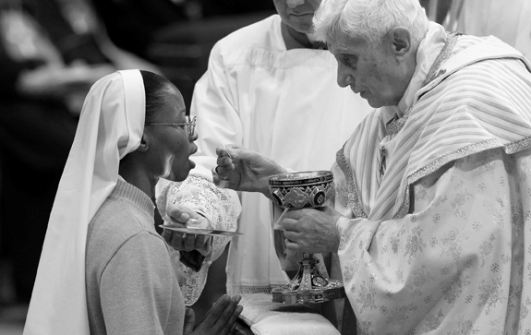
The Acts of the Apostles[a] (Koinē Greek: Πράξεις Ἀποστόλων, Práxeis Apostólōn;[2] Latin: Actūs Apostolōrum) is the fifth book of the New Testament; it tells of the founding of the Christian Church and the spread of itsmessage to the Roman Empire.[3] Acts and the Gospel of Luke make up a two-part work, Luke–Acts, by the same anonymous author.[4]
Traditionally, the author is believed to be Luke the Evangelist, a doctor who travelled with Paul the Apostle. It is usually dated to around 80–90 AD.
< Introduction part of the Book of "Acts" on Wikipedia.org. >
After Jesus was executed, the reason why missionary work was possible without major interference was presumably because Jewish Christians kept the policies friendly to Judaism, even though Christianity was attacked sporadically by Jews.
Chapter 11 of Acts Acts chapter 11 describes the missionary work of the Jews, who were hostile to the ungodly Gentiles, as "the victory of Judaism over devouring the Gentiles."
Let's compare whether this was Peter's vision that actually happened or whether it was a fabrication of the author of Acts.
Luke showed considerable ability for fiction in his first epistle, the Gospel of Luke, written to the high priest Theophilus.
Among the four Gospels, Luke is the only one that makes Mary, the mother of Jesus, and Elizabeth, the mother of John the Baptist relatives and writes about the "revelation and completion" that the priests valued more than historical facts.
John the Baptist, who was beheaded while swearing at Herod, a Gentile king, was a patriot who was considered a hero by all the people of Israel. Luke matched John the Baptist and Jesus as brothers, and their mothers as relative sisters to relieve the wrath of the priests' group against Jesus.
Let me explain the reason why "Quelle" ("source" in German), which overlaps with the Gospel of Matthew and Luke, comes from. This overlaps took place because when Luke wrote the Gospel of Luke, the contents copied from the exaggerated fat and long Gospel of Matthew naturally overlap with the Gospel of Luke.
When writing the Gospel of Luke to high priest Theophilus, Luke referred to the first Gospel of Mark and the second Gospel of Matthew, and also added his own special contents unique to the Gospel of Luke.
Because of the unique and special contents that appear only in the Gospel of Luke, the question of why Luke wrote the Gospel of Luke in particular could be solved.
Among the four Gospels, these verses are the ones created only by Luke's Gospel to tie Jesus and John the Baptist together in a brotherly relationship.
Mary meets Elizabeth Birth of John Conception of John the Baptist
The fact that Luke added special parts that appear neither in Mark nor in Matthew, such as Jesus raising the dead, is also thought to be Luke's over-action to impress the high priest Theophilus. Raising from the death
Not only in the Old Testament but also in the New Testament, there are passages that stimulate the one-sided pride of Judaism, like minefields on a battlefield, so even if orthodox use violence based on the Christian Bible, it can be justified as an expression of religious belief.
Many theologians have speculated for centuries that a man named Theophilus was one of the high priests, as Luke stands out for his talent in emphasizing "revelation and completion," the parts that the priestly group puts more importance to. For this reason, it is more persuasive to believe that the fact that Peter's vision was written in Acts, Luke's second epistle, was not factual, but rather that Luke created and included a part that priest Theophilus liked.
(Acts chapter 11)
The reason Luke, as a disciple of Jesus, was able to write letters specifically to priests may have been because his profession as a surgeon made it relatively easy for him to approach the Jewish upper class.
Success or failure of spraying "son of God" paint job over poorly executed Jesus
decides the fate of all Judean Christians, to be or not to be, which had to be
desperately perfect and ultimately exclusive.


7. Jews are the biggest victims of the man-made "Judaism."

Not only Jews, but any people who were in the position of Jews would have no choice but to blindly believe in Judaism, which mankind has mistakenly believed to be the root of Christianity, the religion of mankind.
For that reason, the fact that Jews have been persecuted for Christianity since Jesus and the persecution of other ethnic groups is not just a problem for Jews, but a task that all of humanity must solve together. This is because correct knowledge has been denied and threatened by the emotional agitation of many.

Humanity must now maturely liberate itself from the racism and nationalism created by conservative Christianity and Judaism, which are the fundamental causes of mankind's horror killings in wars every single day around the world. This would be an easy task if intellectuals around the world unanimously acknowledged the intellectuals' natural duty of telling the "truth."

Just as all the superstitious religions created by the ancients enforce coercion and wrong judgment, if you arbitrarily combine the Bible verses in conservative Christian ethics, which has been sewn with wrong buttons and has amplified errors, you can infinitely produce "evil capitalism of devilish Bible verses" alike created by Max Weber like cruel racist and warmonger. Isn't it an obvious task that theologians should establish the right order of fundamental ethics, truthful judgment of humanity, and social justice?

It is none other than the Bible, Christianity, which is the “religion of love and eternal life,” that has justified and driven humanity into the abyss of destruction through endless inter-national wars and murderous materialistic competition in the human world, and the evil spirit of nationalism and opportunism that humans have mistakenly believed to be the mother religion of this, Judaism.

They tempted humans with the sweet fragrance of “love and eternal life,” in the name of religion and eventually poisoned the well that all mankind drank from, resulting in destruction. These absurd evil spirits are none other than the superstitious groups of conservative Christianity, Judaism, and Muslim.

It is true that in the early days of human civilization, they contributed to the unity of the people and society in the name of religion, but in modern society, when obvious contradictions and falsehoods are revealed, the only group that can stop these people from repeating fanaticism and superstitious violence is the group of “theologians” whose vocation is establishing social order with accurate knowledge.

Evildoers, such as Netanyahu of Israel, who are justifying the killing of 100 times more victims than their own by the cheap illusions created by the priests of "People of God," should be arrested as "war criminals" like Hitler and Stalin !

Almost all law school professors and intellectuals in Korea are silent on the corruption of those in power that condones the sordid crimes of the First Lady, who has multiple witnesses who have witnessed her work as a former call girl. Her mother is an ugly, wicked woman who falsely accused her business partner of being a fraud and had him sentenced to two years in prison, but most law school professors and intellectuals do not even mention it and just turn a blind eye. Don't you think that this alone is a dirty and shameful crime?

If a group of modern intellectuals does not ponder the question of whether they are fulfilling their responsibility and mission to human society or whether they remain an opportunistic elite group that turns a blind eye to crimes of lies and violence, then they are no longer intellectuals. It is true that many intellectual groups in China, Russia, the United States, Korea, and many other countries have enjoyed the privileges of intellectuals without fulfilling their mission and responsibilities.

Most ordinary citizens around the world do not even have the basic knowledge to judge the evils of "cryptocurrency," "Judaism," "conservative Christianity," "nationalism," and "capitalism." Just as almost everyone in the world uses a smartphone, but there is no need to study the scientific knowledge that goes into making a smartphone, when it comes to difficult religious issues that cannot be judged as right or wrong by common sense, theologians and intellectuals should take the lead in informing the world of right and wrong.

As an American citizen, I have been a victim of the atrocities committed by the Korean judiciary and political power for the past 20 years, but not a single Korean media outlet has even reported on this to the public.

I do not hesitate to call the Korean politicians, law school professors, judges, intellectuals, and media professionals who have long known this fact and yet turned a blind eye to it a "group of criminals." An intellectual who does not ponder over the correct value of social conscience is not an intellectual but only a cheap street merchant.

Jewish scriptures have the ample amounts of easy-to-understand ethics with brilliant ancient myths "Genesis" alike, which could answer to almost anything that ancient people wondered.

8. Netanyahu Trump Xi Jinping's Cigarette Smoke Power,
& “Power of Conscience.”

The power of these madmen is possible because the basis of their power is empty facts, propaganda, and the following of a few thugs. In the world of pure ideas, it is nothing but the playful violence of swindlers who are full of shame and lies, so it is as shabby, dirty, and childish as cigarette smoke.
Back-alley thugs also have the power to threaten and kill people with weapons, but this is only a lethal assault possible in the world of back-alley thugs, but in the open, bright public universe, it is nothing more than a dark prank crime that is immediately punished. If we are citizens of a just universe ruled by a just God, we must gather our strength to arrest and punish these heinous criminals as quickly as possible.
The world you live in could be one where injustice triumphs over justice, or you remain silent because you are not sure what is justice and what is injustice, but in God's world where I live, Netanyahu, Trump, and Xi Jinping are clearly nothing but evil, criminals, and madmen who had to be arrested and punished right away.
Even if the wicked have armies armed with guns and deadly weapons, those numerous armies and deadly weapons are no match for the order of God, the owner of the ocean heart that rules the world of souls, if they are run by human souls. This is because, just as all internet in the world is connected through the hub country of the United States, all soul-bearing immortal animals are observed, judged, and governed in the realm of God, the absolute being of the soul.
No matter how vast and magnificent the universe is, minerals, plants, and animals that do not have souls have no judgment, so they are ruled by animals with souls, and again, humans, who are limited soul beings, are governed by the absolute soul being called God.
The closest divine being we have to a ruler in the transparent world of the soul is Jesus Christ, who has full evidence throughout history of having traveled between the worlds of life and death.
Just as we need to report to the police when we see gangs running wild in our neighborhood, we need to pray a two-way dialogue about the various problems that our human society is suffering from, asking Jesus Christ (not superstitious Jehovah as before) directly how to respond, and praying for judgment.
Just as an evil spirit cannot resist a trial in a court where clear evidence and sound logic rule, the instigation of evildoers like Putin, Netanyahu, and Xi Jinping cannot avoid judgment and repeat their sins in the "universe definitely ruled by spirits," even though madmen can gather for a while to conspire and commit evil deeds.
This is the same logic that one plus one equals three, which the wicked can sing for a while in the underworld but cannot be justified before the judgment seat of the souls of the universe. https://suban.com/light.htm
"There is nothing hidden, except to be disclosed; nor is anything secret, except to come to light." (Mark 4:22) Isn't this Jesus' plain teaching a historically proven truth of our human society for a long time?
In London, England, countless CCTVs are recording everyone's daily lives, so every moment of every person can serve as evidence for trials and investigative agencies when an incident occurs. But what is it that we humans can hide and make excuses for in front of the "Soul Activity Archive" where everything in the human world, created by God whose science is more than a million years before England, is recorded?
Even now, 60 years later, I still feel God's record of my bad behavior, such as being mean to my housemaid and being mean to my poor neighborhood friends when I was a child, and I repent with a heart of repentance, asking for forgiveness from those people long ago and praying for their lives.
Have you ever wondered about the personal records you have accumulated while living in this world and how they will fare in the judgment seat run by God?
It is a "sin" and a "crime" that we, the intellectuals, armed with knowledge and conviction, remain silent and indifferent while seeing the murderous suffering of most of humanity who lack knowledge, are hungry, and are abused.
The door of the Lord's church, which is the window through which humanity must restore true dialogue and where humanity must meet to discuss and pray for eternal peace, is always open to you.
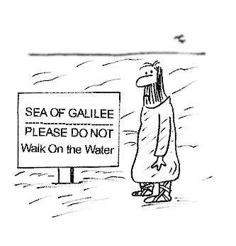

9. Why is an woman “the sinner of the original sin” in the Bible ?

Ancient people (and even today's poor people in the world) had a custom to throw away female babies as soon as they found the new babies were female (female infanticide).
1, They did not have birth control and their food supply is very limited when the male children could make much more labor and productivity than female children even though they consume same amount of food and time, which decides a critical economical loss.
2, Even when the parents sell their children to patrons in order to feed not only children but also parents, strong male children could get paid a lot more than female children.
3, The usefulness and the value of female civilians to the rulers is a lot less than male civilians whom could be switched to the military in case of national crises and corvee like free labor.
4, The rulers in small countries with limited food supply wrestling with survival issues could have set up a strategy to limit the number of female civilians whose community value is a lot less economical and more limited than male civilians.
The rulers might need to kill newly born female babies in order to meet the survival calculation.
5, The rulers of the opponent nations on the contrary, had to kill the male babies in colonies, or opponent countries in order to suppress the increasing monotonic of the population i.e. Herod's massacre (Matthew 2:16,) and Pharaoh's massacre (Exodus 1:6-22) in Bible.
6, The norms of a couple and a family of a good majority of low class ancient people could not be easily imagined by today's ordinary people with abundant supplies. The shortage of female members in community had to result in prevailing of the homosexual land the bestiality among low class ancient males who could not afford heterosexual partners. (Bestiality and Zoophilia: Sexual Relations with Animals) Ancient people had to wait many months before they find out if the new babies were male or female, in a little similar process of waiting for the results of expensive lotteries.
The male birth means a luck, while the female birth means loss and critical bad luck. This kind of economic situation could have led ancient people to set up a fortune theory of luck or bad luck, mythologizing where the bad luck had come from, creating grisly curse to all women as "the incurable fatal seed of the sin" like in the Genesis one.
Woman is described as a form of an incomplete and deviated being whom is made of a part of man's body, whom has made man be deported out of the paradise for good. (Genesis chapter 2), Ancient people imagined why a man is made of dust on the ground by seeing that a dead body turned into dust on the ground, whose imaginations had piled up and triggered Genesis writers to state the origin of mankind, and animals in the world.
The solid authoritative concepts of God as the potter and women as his sinful creatures have
been transcended to Jeremiah chapter 18, Isaiah chapter 29, and till Romans chapter 9 of apostle Paul, which has constituted "sinner women" firmly in Christian world until now, admired
and observed even by learned intellects in very well developed western countries.
A Half of the human population have been suffering from this ridiculous Biblical superstition directly or indirectly in all Christian countries and the countries with similar kinds of religions in the world.
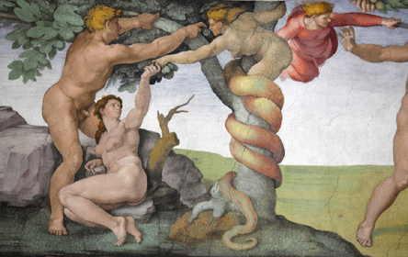




www.PopeinUkraine.com
10. Why is a man made of mud?

A good many ancient people all around the world believed that a man is made of mud with the reasons why :
1, They saw human body turns into only dust and the bones after the death, "stop of the breathing."
2, "Clay" is the easiest material to form a vivid figure of a human body, carving and coloring are possible after the first form of assembling which can copy the real human figures except for breathing.
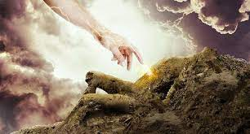 
Ancient myth of "a man is made of clay" appears in the myth of ancient China, which is much older than the making of the Genesis in Israel. Ancient myth of China tells that female God (女媧Nǚwā)made a man out of clay after the deluge, which has a many sibling kind of old tales in the Eastern countries around China.
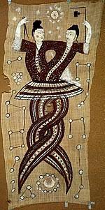 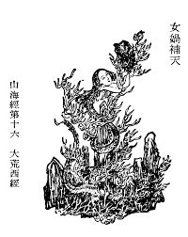
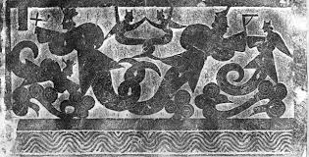
In Greek mythology, Prometheus and Epimetheus were spared imprisonment in Tatrus because they had not fought with their fellow Titan during the war with the Olympians. They were given the task of creating man.
Prometheus shaped man out of mud, and Athena breathed life into his clay figure, which is a identical same structure of the Genesis.
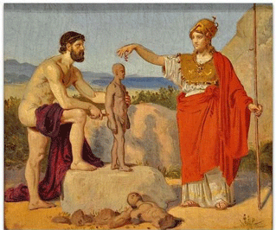 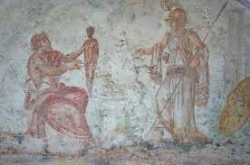

"A Man is made of clay" looks like not only a regional myth or a myth of local superstition, but also "a firm belief "of a good many ancient people when you see quite countless quantity of clay soldiers guarding Mausoleum of the first Qin Emperor in 3rd B.C. with vivid individual face figures.
Several thousands of clay soldiers and horses with vivid each individual figure could not be possible, unless such a myth was counted as "the truth or public religion."
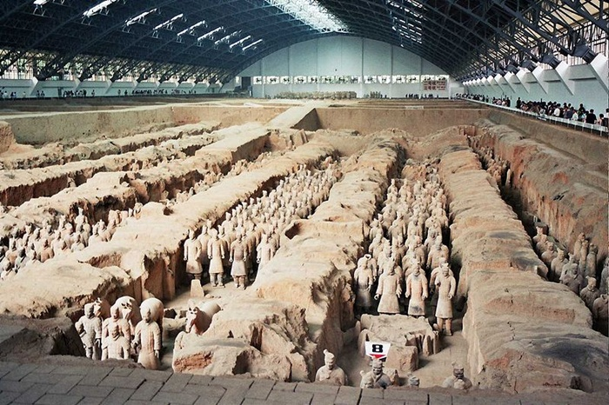

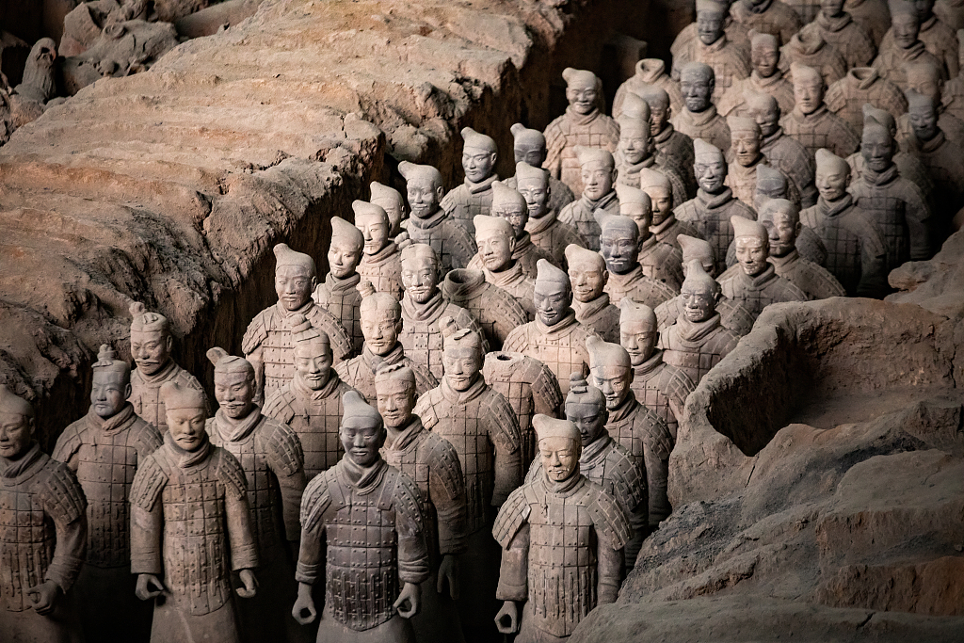
11. Religious ecstasy in the Hebrew Bible "book of Job."

Most politicians make a living by gaining support through lies and propaganda, and this "political commercialism" is a representative virus form of civilization that has continuously polluted and destroyed humanity.

The priestly group who wrote the Hebrew Bible and led the Hebrews used the dramatic effects of religion to agitate the people and maximize their own interests, so the wealthiest elite group at the time of Jesus was the high priests.
The priestly group was encouraging fanaticism for the sake of their own vested interests, not for the sake of religion.

Communists are carrying out the essential fraud of educating the people with ideology and turning them into their robot puppets. The Jews, who are the biggest victims of the frauds of the Hebrew Bible, which was written to justify the "unity of politics and religion," should first correctly realize the true nature of the manipulation written in the Bible.
The reason why most groups of priests indulge in illusions through repetitive religious practices to perform the profession of religion, even if it is not their purpose, is because religion is a difficult field that requires correct knowledge.

"Job" is a book in the Hebrew Bible that was created to lead innocent people to believe in Jehovah, the Jewish religion, and to be blessed with material blessings at the end if they endure extreme pain and damage that they cannot bear.

The purpose of this book is to drive innocent people into a dead-end submission by blindly following the superstitions of self-deception, a human-made belief in Judaism, and to relieve all suffering, but this ridiculous plot is still held up by many theologians and famous clergies as a conservative "Christian virtue."
"Following the "holiness" manipulated by the priests is "justice," which is the iron rule of Judaism like superstitions.

Just as communist violence, wielding sickles and hammers to spread communist ideology and executing those who opposed it, Jewish priests had repeatedly led ordinary people into the trap of blind Jehovah-ism and nationalism.
The reason why many Jewish priests still blindly repeat and recite the Hebrew Bible at the Wailing Wall is because their superstitious belief that Judaism is the root of conservative Christianity and Jesus is what binds them.
The breaking of the false and brittle glass of Judaism will not be an insult to the Jews but will be their "Liberation."

The violence of superstition that ruled ancient societies, where people had no choice but to live based on limited knowledge and judgment, continues to thrive in the modern knowledge information society, suppressing human development and happiness. This is human hypocrisy and violence that must not be repeated any longer.
The pollution of superstitions that oppress and abuse humanity can no longer be justified under the sweet and nasty pretext of “freedom of religion.”

If the hypocrisy of intellectuals turn a blind eye to this kind of habitual contradiction and coercion continues, even if mankind develops scientific civilization ten times more than it is now, mankind will still have to groan in the pain of the whirlpool of war, conflict, and famine.

Moreover, the Jewish Bible, which insists that other nations and countries are eternally subject to the Jewish people of Israel, is a criminal superstition that threatens the peace of mankind all over the world, and mankind has a duty to define it as a “criminal superstition.”

Israel, which has repeatedly committed brutal murders, should be designated as a criminal and violent state!

7 Even when I cry out, "Violence!' I am not answered; I call aloud, but there is no justice. 8 He has walled up my way so that I cannot pass, and he has set darkness upon my paths. 9 He has stripped my glory from me and taken the crown from my head. 10 He breaks me down on every side, and I am gone, he has uprooted my hope like a tree. 11 He has kindled his wrath against me and counts me as his adversary.
12 His troops come on together; they have thrown up siegeworks against me and encamp around my tent.13 "He has put my family far from me, and my acquaintances are wholly estranged from me. 14 My relatives and my close friends have failed me; 15 guests in my house have forgotten me; my serving girls count me as a stranger; I have become an alien in their eyes. 16 I call my servant, but he gives me no answer; I must myself plead with him. 17 My breath is repulsive to my wife; I am loathsome to my own family. 18 Even young children despise me; when I rise, they talk against me. 19 All my intimate friends abhor me, and those whom I loved have turned against me. 20 My bones cling to my skin and to my flesh, and I have escaped by the skin of my teeth. 21 Have pity on me, have pity on me, O you my friends, for the hand of God has touched me! 22 Why do you, like God, pursue me, never satisfied with my flesh? (Job chapter 19)

10 And the Lord restored the fortunes of Job when he had prayed for his friends; and the Lord gave Job twice as much as he had before. 11 Then there came to him all his brothers and sisters and all who had known him before, and they ate bread with him in his house; they showed him sympathy and comforted him for all the evil that the Lord had brought upon him; and each of them gave him a piece of money and a gold ring. 12 The Lord blessed the latter days of Job more
than his beginning; and he had fourteen thousand sheep, six thousand camels, a thousand yokes of oxen, and a thousand donkeys. 13 He also had seven sons and three daughters. (Job 42:10-13)

33 the Lord our God gave him over to us; and we struck him down, along with his offspring and all his people.34 At that time we captured all his towns, and in each town, we utterly destroyed men, women, and children. We left not a single survivor. 35 Only the livestock we kept as spoil for ourselves, as well as the plunder of the
towns that we had captured. (Deuteronomy 2:33-35)

The Book of Job (/dʒoʊb/; Biblical Hebrew: אִיּוֹב, romanized: ʾĪyyōḇ), or simply Job, is a book found in the Ketuvim ("Writings") section of the Hebrew Bible and the first of the Poetic Books in the Old Testament of the Christian Bible.^{[1]} Scholars generally agree that it was written between the 7th and 3rd centuries BCE.^{[2]} It addresses the problem of evil, providing a theodicy through the experiences of the eponymous protagonist.^{[3]} Job is a wealthy and God-fearing man with a comfortable life and a large family. God asks Satan (הַשָּׂטָן, haśśāṭān, 'lit. 'the adversary'') for his opinion of Job's piety. When Satan states that Job would turn away from God if he were rendered penniless, without his family, and materially uncomfortable, God allows him to do so. The rest of the book deals with Job successfully defending himself against his unsympathetic friends, whom God admonishes, and God's sovereignty over nature. < in wikipedia.org >

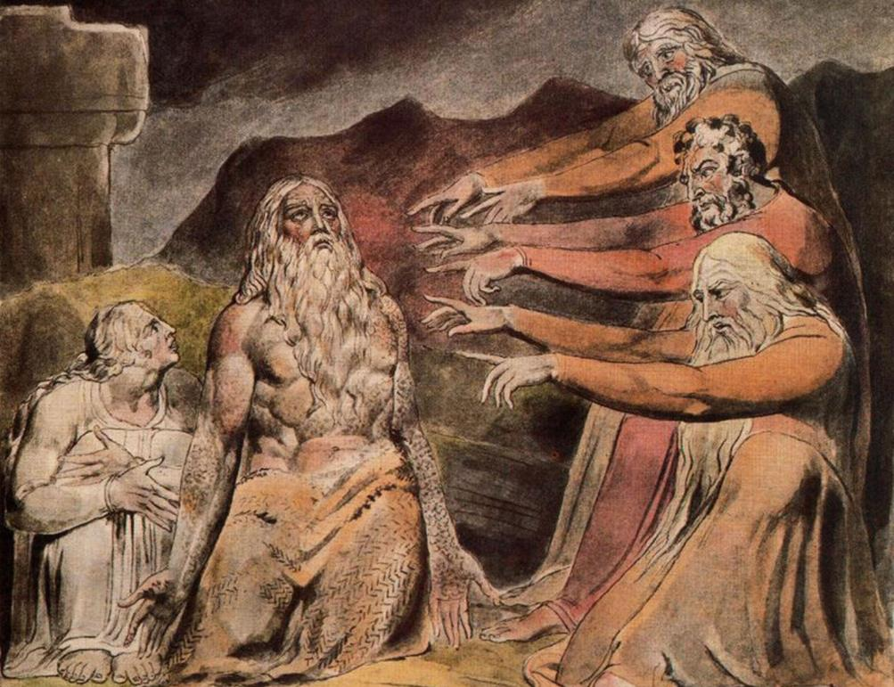

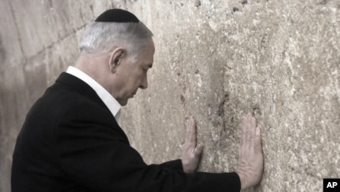

12. How densely are "holy scriptures" polluted for opportunistic nationalism?

There are countless cases where evidence and witnesses are cleverly manipulated in trials, even in modern society where information is made public, judges are bribed, and righteous people are sentenced guilty as criminals, and criminals act as righteous people. Just as many judges and evil elites in Korea wash their “sin” in the church, the existence of Jesus has been used to easily wash away the sins of the wicked and to instill fanaticism of the national religion Judaism in wicked people like Netanyahu.

This is a complaint I heard from a foreign friend about the barbarism of her country's people:
"They eat everything, and when they eat anything else, they advertise it as 'medicine'."
Judaism had no choice but to focus on “nationalism" based on the "unity of religion and politics" as a very small country in the Near East, surrounded by powerful countries. Judaism has been habitually repeating among its priests, taking for granted ANYTHING of oppression and violence in the form of holy scriptures.

The way Matthew, who is attributed to be the author of the Gospel of Matthew, maintained an opportunistic profession as a tax collector in Roman Empire hated by the Jews, and packaged Christianity as a derivative of Judaism after Jesus was executed is an example of a criminal desperately struggling to escape the charge of death, and thoroughly manipulating evidence and witnesses of his executed Lord Jesus.
The Gospel of Matthew is a compilation of the tricks by a clever tax collector to avoid the death penalty when there was a Jewish "holy war" movement to wipe off all believers in Jesus. https://suban.com/prosecutor.htm

Throughout human history, many nouveau riche and upstarts have been found to have manipulated their genealogies to justify their rise in status. As a servant of the Roman Empire, Matthew, who was financially stable by collecting taxes from the Jews, also likely falsified his genealogy to wash away the meanness of living as a tax collector, which was condemned by the Jews.
Clever Matthew begins his Gospel by grandly fabricating the genealogy of Jesus to emphasize that Jesus was a loyal descendant of Judaism.
https://www.biblestudytools.com/nrs/matthew/1.html

Even for beginners in theology, it is easy to guess the desperate situation of Matthew, just by looking at the absurdly exaggerated editing of the passage where Jesus warned disciples not to call him the Christ, the Son of God. https://suban.com/whoisjesus.htm Jesus simply warned his disciples not to call themselves Christ, a title that would have resulted in their being arrested for treason. Matthew's lengthy sermon-like editing of the original Gospel of Mark is as absurd as adding three pizza toppings to a beef steak.
https://suban.com/egypt.htm Jesus was portrayed as a national hero who survived persecution by foreigners, like the birth of Moses, the Jewish hero who saved the Hebrews from Egypt.

(Exodus chapter 1 and 2)

15 The king of Egypt said to the Hebrew midwives, one of whom was named Shiphrah and the other Puah, 16 "When you act as midwives to the Hebrew women, and see them on the birthstool, if it is a boy, kill him; but if it is a girl, she shall live."
17 But the midwives feared God; they did not do as the king of Egypt commanded them, but they let the boys live.

1 Now a man from the house of Levi went and married a Levite woman.
2 The woman conceived and bore a son; and when she saw that he was a fine baby, she hid him three months.
3 When she could hide him no longer, she got a papyrus basket for him, and plastered it with bitumen and pitch; she put the child in it and placed it among the reeds on the bank of the river. 4 His sister stood at a distance, to see what would happen to him.
5 The daughter of Pharaoh came down to bathe at the river, while her attendants walked beside the river. She saw the basket among the reeds and sent her maid to bring it.
6 When she opened it, she saw the child. He was crying, and she took pity on him. "This must be one of the Hebrews' children," she said.
7 Then his sister said to Pharaoh's daughter, "Shall I go and get you a nurse from the Hebrew women to nurse the child for you?"
8 Pharaoh's daughter said to her, "Yes." So, the girl went and called the child's mother.
9 Pharaoh's daughter said to her, "Take this child and nurse it for me, and I will give you your wages." So, the woman took the child and nursed it.
10 When the child grew up, she brought him to Pharaoh's daughter, and she took him as her son.
She named him Moses, "because," she said, "I drew him out of the water."

Emeritus Professor of Harvard Divinity School, late George Ernest Wright and his book "Biblical
Archaeology."

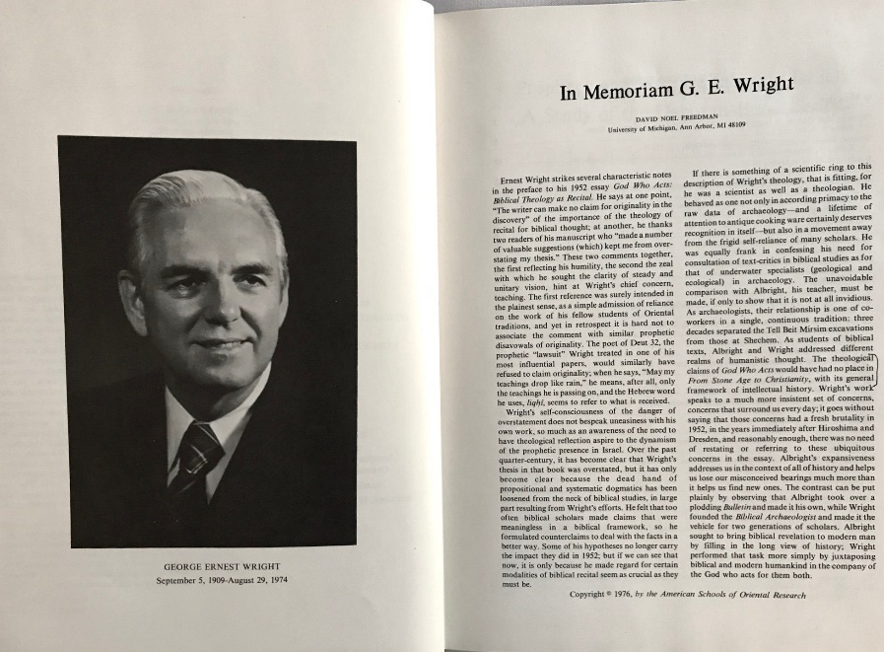
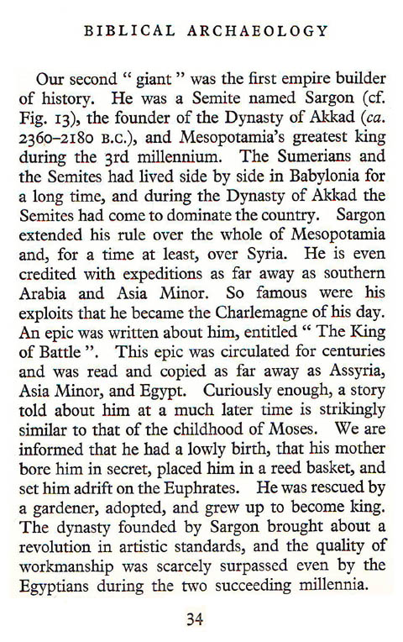

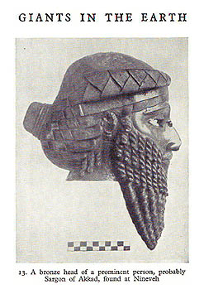
"Moses" may have been a popular name in Egypt at the time because of the anecdote about Sargon.

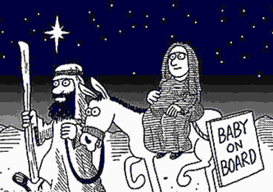

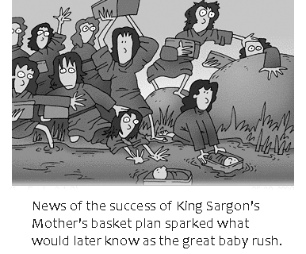

Let's roughly figure out the psychology of the Hebrew priests and Jews who created Judaism and wrote their scriptures, and the group of fanatics who are blind followers.

First generation.

Scribes and priests are to devise and produce religious scriptures suitable for the "unity of politics and religion" for the ruling power that is their sponsor. Here, the justice of the innocent people means obedience to the ruling power that is "holy." Scribes and priests can tell what is real and what is made up at least. (Deception)

Second generation.

If there were any flaws in the Bible made up by the first generation, they should be corrected. For example, if the Lord of Israel said that He would protect Israel with omnipotence and power, and then Israel was conquered and taken captive, then an "explanation and justification" for this would have to be made.
To justify the Bible made by the first generation, the second generation made up an excuse that Israel was not faithful enough to Jehovah and that Jehovah used other nations to conquer Israel and "discipline" them.
The second generation either does partial patch jobs or creates new books to accomplish this task.
(Justification of Deception, and self-illusion)

Third generation.

They can hardly discern what had been deceived and what had been deluded exactly before.
The accumulation of the works of deceptions of their forefathers has enforced them to be only submissive and proud of history fabrication, which assures them of high-class initiatives. Their sole choice of survival is the definite defense of the scriptures and total submission to the high priests.
All amounts of deception and chastisement have been adjusted and repaired by the illusive mode of the second generation yet. What is left over is only something they are to be totally absorbed in the perfect
text and scripture fabrication. (ILLUSION)

Fourth generation.

In a situation where it is difficult for a monarchy to exist as an independent nation due to the surrounding powerful countries, the ruling class becomes families of high priests and uses the power of the scriptures created by their ancestors keep taking advantage of their people in the name of religion.
The violence that arises from the contradictions of their one-sided religions is bound to be further aggravated by extremists, and the inevitable contradictions of religion again create various sects and become a potential powder keg of a state, like the sectarian struggles of Islam. (Fanaticism)

What is Hebrew? in "Biblical Archaeology" by George Ernest Wright

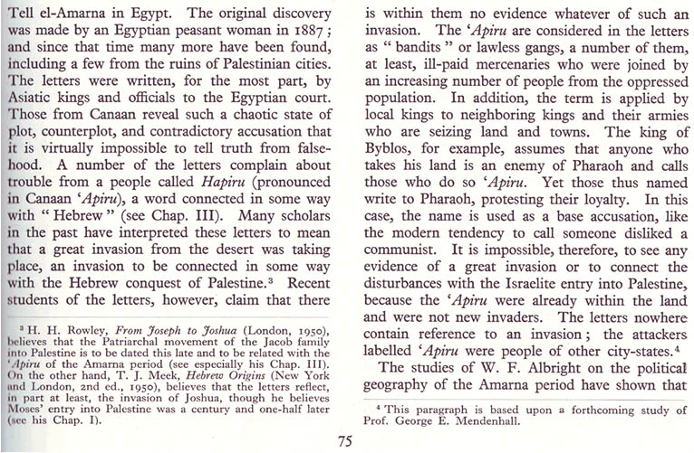

What is Moses then? by Robert B. Coote, a former student of G. E. Wright and F. M. Cross at Harvard.

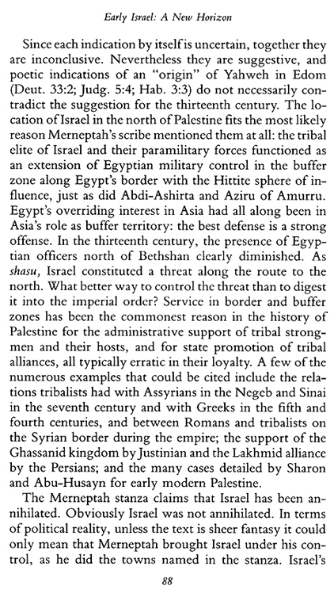
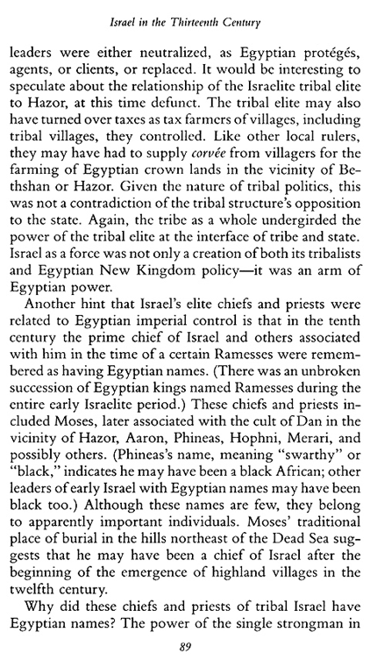
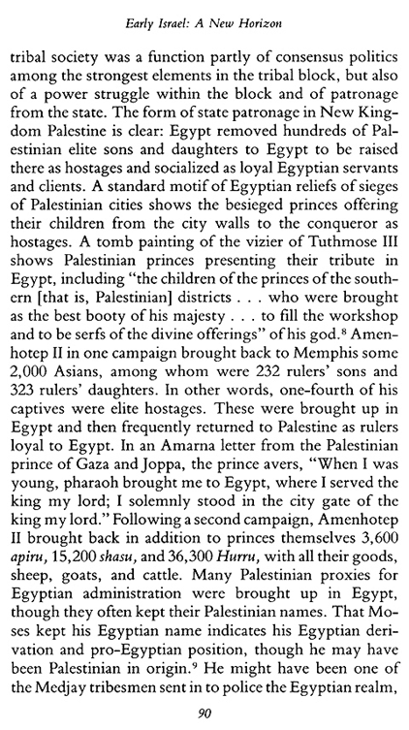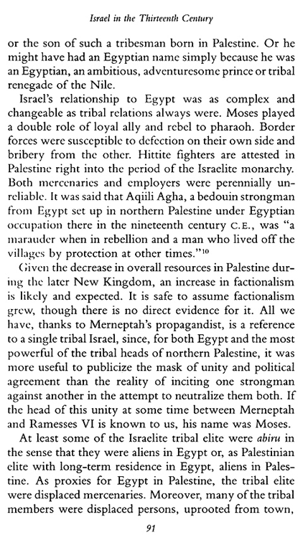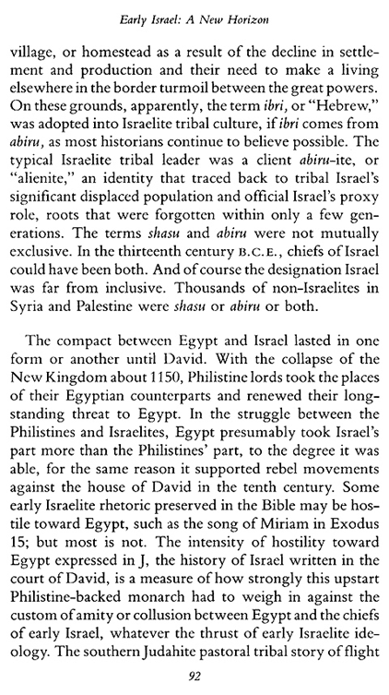
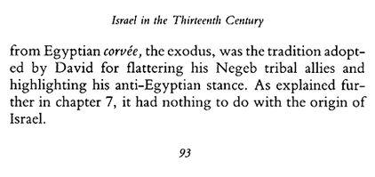
13. What a bad gold digger Korean first lady "Julie." 1

After the South Korean presidential election, several media outlets, including Le Monde, reported rumors about his wife working as a call girl, but all the media in South Korea kept their mouths shut as if they had promised.
The reason why Korean media cannot report the "truth" is because almost all media in the world are now connected to large corporations such as conglomerates and cannot operate without submitting to their interests.
The same goes for the United States, where the Washington Post or Time Magazine are subject to boycotts if they offend Jews, so the spirit of Pulitzer reporting the truth in the United States has long since died.

Even though the world today is called a modern information society, democracy in which citizens are the masters has long since died, and in a world where vicious capitalism and nationalism and terrorism are commonplace, the expression "hell" is an appropriate word for describing today's modern society.
It has become an undeniable fact of modern society, with 8 billion people living together, that intellectuals and scholars are so afraid of attacks by terrorism, interest group nationalism, and racists that they cannot speak openly about even "academic truth," and they try to disguise their timidity and cowardice as "academic purism."

In Japan, a country where conspiracies and tricks are more common than the others, there is a rule in their commerce world that "the concubines of the chief prosecutors are managed by conglomerates."
The wisdom of Japanese conglomerates and businessmen who use the private lives of prosecutors as bait to create a way out of their crimes has a long history in the unique and closed environment of the island nation of Japan.
Why doesn't Britain, which is also an island nation, have such a closed and gloomy tradition? Britain is a Christian nation so there is no such closed conspiracy, but instead, there is still classism in the form of the aristocratic group.

It is estimated that Japan began to use their traditional gold-digging tactics against Korea in earnest around the time when it felt a sense of crisis as South Korea and North Korea began to grow closer by signing a peace treaty.
It is only natural that Japan, which had limited defense power after World War II, would plot political conspiracies against its hypothetical enemy, Korea, by collaborating with conglomerates and intelligence agencies.
Japan had pro-Japanese friends in Korea who bowed down to their power and money, and had a tight intelligence network of conglomerates all over the world that could rival the CIA in the United States.

The roots of pro-Japanese forces in Korea are deep and extensive, and Korea was incomparably lenient toward pro-Japanese forces compared to France, which executed ten thousand of pro-Nazis.
Park Chung-hee, the dictator who revived the economy of the poor country of South Korea, was a former Japanese military officer who graduated from a Japanese military academy, and the Chosun Ilbo and Dong-A Ilbo, which dominate the media in South Korea, are like loyal dogs that swore allegiance to the Japanese emperor every year.
They have been forming a natural alliance with Japanese imperialists who are plotting to infiltrate Korean politics.

They are the conglomerates with money, the power created by that money, and the media group that flatters the money.
I call that group the "Nippon Club" for convenience.
Lee Byung-chul created the Samsung Group and began investing in semiconductors after receiving advice from Japanese
entrepreneurs. His son Lee Gun-hee created Samsung's golden age, and the current Samsung chairman is his grandson.
There have been long-standing rumors that Lee Gun-hee's mother was Japanese, as he fought fiercely with his two older brothers over inheritance and turned his back on Lee Byung-chul's lawful wife.
Lee Gun-hee went to school in Japan and had close relationships with many Japanese people.

Lee Byeong-chul, Lee Gun-hee, and current CEO of Samsung Lee, Jae-yong.

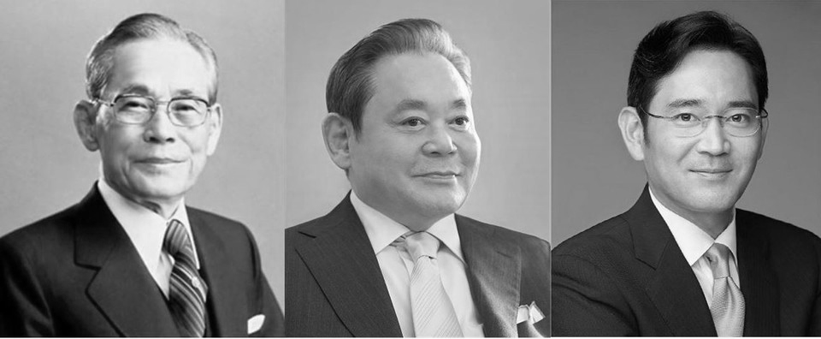

The first lady of Korea's name is Kim Gun-hee, but this name was changed in the process of laundering her identity as there are many witnesses who say she worked as a call girl in the past. In particular, the fact that she changed her name to "Gun-hee" is because she loves money and blatantly expressed her desire to make a lot of money like Lee Gun-hee, the richest man in Korea.
Kim Gun-hee, whose nickname was "Julie" when she was working at a nightclub, is now involved in several corruption and crimes due to her beast-like nature of doing anything for money.
The reason her nickname at nightclub is Julie is because she liked jewelry very much.
A female civic attorney who mocked her by asking if she knew how to spell jewelry correct was recently found not guilty after being charged with defamation.
Julie didn't just change her name; she also had several facial surgeries that transformed her face into a completely different person.
Not only that, Julie earned a doctorate and a professorship at Kookmin University, but the signatures of several professors who passed her doctoral thesis were in the same one man's handwriting, so it is suspected that Kookmin University bribed Julie, who was in power, with the doctorate and professorship. (their home page www.kookmin.ac.kr )
Julie's mother falsely accused her partner of being a fraud to steal his assets, leading to an unjust two-year prison sentence, proving that the Korean judiciary hell is corrupt quite enough to be included in the Guinness Book of World Records.

Why don't you let me compile the crimes of Nippon Club, including Julie's 2nd and 3rd parts, and email you again within a few days.



The signatures of several professors who passed her doctoral thesis were in the same one man's handwriting,

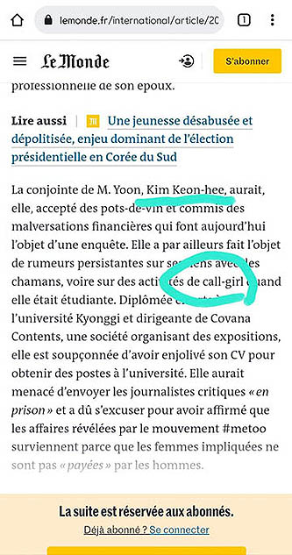
13. Samsung arranged the gold digger and chief prosecutors. # 2

The person who introduced Julie to his college juniors, two promising chief prosecutors from Seoul Law School was the vice president of the pro-Japanese association, Cho Nam-wook, who also graduated from Seoul Law School, and the company which provided them with a place for their romantic affair was Samsung.
Samsung has been managing judges and prosecutors on a large scale at the group level and reaping profits.
Cho Nam-wook was the owner of the hotel where the nightclub Julie worked was located and it was believed that the one who gave Julie special favors, such as professor's job at Kookmin Univ. However, the witnesses who said Cho frequently called "Julie" to his room withdrew their testimony when the prosecutors' office started to question them.

The chief prosecutors who lived together with Julie in different apartments of luxury Acro Vista mansion provided by Samsung are Yang Jae-taek and Yoon Seok-yeol, who later became the current president. Julie's occupation is not only a college professor and hostess at night club, but also an art curator at later time.
Considering that the group who helped her build her curatorial career big are Japaneses, it is possible that Cho Nam-wook, the vice president of the pro-Japanese association, and Japanese nationalist groups have invested in Julie for a long time for the sake of the big projects of Nippon club.

In addition to the routine court and prosecutorial lobbying, Samsung also has many legal tasks to get through in Korea, such as high inheritance taxes on the inheritance of new CEO Lee Jae-yong's assets, etc. etc.
In the past, Korean conglomerates used to collect illegal election funds to ensure the victory of the conservative party, put them in a car, and deliver the entire car. It is presumed that they have been holding organized meetings for a few decades to secure the political power of the party they support.
Looking at the situation over the past 20 to 30 years, it seems that the Nippon Club has been formed and is either learning or imitating the techniques used by the Japanese nationalist Party to carry out one-sided politics.

Samsung has its own media power, Hyundai has its own newspaper, and even Moonie's Unification Church has its own newspaper, and the traditional pro-Japanese media conglomerates Chosun daily news and Dong-A daily news are leading them, and they have been moving to take over even TVs for several decades.
They seem to believe that if they take control of the prosecutors' office, they can completely take control of
Korea, and it looks like they started to use gold digger strategy against the chief prosecutors based on this idea. Media reporters who exposed such corruption and conspiracies of the elite in such detail had their homes and businesses searched and seized by the police or were prosecuted.
Does it mean that there is no counter-political force in Korea that can stop them?
The opposition party, which lost to Yoon Seok-yeol by a narrow margin and took control of two-thirds of the National Assembly, unfortunately has the dismal truth that they are more corrupt than the Yoon Seok-yeol group.

Lee Jae-myung, a former presidential candidate, was reported to have erased a dot on his pepper to erase evidence of an affair that was exposed by an actress. (left)
The actress's apartment, which she revealed as the site of her affair with Lee for over a year. (right)
Lee lost the election because he volunteered as a free lawyer for an actress's lawsuit and enjoyed a free affair for over a year and is now facing a prison sentence of around 10 years for various corruption and crimes.

You must agree with Henry Fielding, who said, "Life everywhere furnishes an accurate observer with ridiculous."



13. Did they throw a wild party and film it from behind? # 3

Japanese movie "Flowers and Snakes," has a story about inviting powerful politicians, lawyers, and others to a wild sex party and using their weaknesses to carry out endless evil schemes of hell devil minded people.
In the movie God Father, there is a scene where a senator is framed for murdering a prostitute to manipulate the national politics by the mafia.
Such bizarre conspiracies are not uncommon in history.

In the gloomy environment of Japan, the bizarre plot in "Flowers and Snakes" has considerable realistic plausibility.
Japanese samurai had a rule of not pouring sake to opponents with their left hand because they might stab their opponents with the right hand while pouring. Korea's crisis may have been recorded on a single memory card.

A similarly horrifying incident to the one depicted in the film occurred in South Korea, where a construction contractor was reported to have hosted a sex party and invited many elites, including politicians and lawyers.
This incident is too big to be the work of a single construction worker, and I suspect that it was orchestrated by a Korean who was instigated by Japanese nationalists alike ultimately for the sake of Japan.

It became known to the world when the wife of a construction contractor, who discovered a videotape of the Deputy Attorney General and the contractor having sex with a woman, sued the woman for adultery. There was even a media report that current President Yoon Seok-yeol was invited when he was a civic attorney.

The number of invited individuals was so far beyond the scope of the group, and the scale was so large that it could be considered a group-level event, making it difficult to believe that an ordinary, nameless construction contractor would have learned from an advanced country like Japan in political intrigue and trickery and used it for personal purposes.
It cannot be ruled out that Chung Doo-eon, a relatively conscientious politician who took the lead in announcing that he had attended this party, committed suicide without reason some time later because he felt threatened by the weaknesses exposed by this party.
This incident smells ten times stronger of the dry smell of Japanese SAKE than of the smell of Korean kimchi.

In this world of rampant crime, dominated by evil capitalism and nationalist racism, there are many groups of villains who consider it a virtue, political skill, or courage of patriotism to inflict catastrophic and murderous harm on many people for the very small benefit of their own group.

There have also been claims that the bombing of KAL Flight 858, a Japanese perpetrator involved in the bombing of KAL Flight 858 committed suicide, a North Korean terrorist operation that brought South and North Korea to the brink of war, and the incident in Myanmar in which many South Korean government officials were killed were all part of something Japanese nationalists took part in.

Hebrew Bible says that King David fell in love with the wife of one of his subordinates after seeing her bathing. He sent her husband, his subordinate, to die in battle and took her as his wife, and Solomon was born from her.
Bathesheba was so clever that she made her son Solomon king even though he was not her legitimate heir, and it has been questioned whether she intentionally showed David a bath to seduce him from the beginning.
Just because such an ugly conspiracy and dirty history was written in the Holy Bible as the ancestor of Jesus, the God of Israel became the God of mankind, and Jesus was described as the descendant of such ugly nationalism.
It is very natural that Christianity, as a crazy religion, has caused many misunderstandings and crimes to mankind.

Many Korean pastors and elders use David and Solomon story as examples to justify their adultery, and the cunning deception of Jacob, who got his personal name "Israel," and deceived his father and became the model of Israel, has been used as a “feat holy deception” and has even been an encouragement to many wicked people.
If the Chief Justice, the Prosecutor General, the President, and word's leading scholars were only opportunists who sold the truth, how terrible a hell would that society become?
The Bible is a terrible plague that has provided the world's ruling elite with the principles of brutal nationalist capitalism, and excuse with encouraging them to believe that their cruel and cunning elites can triumph.

Even though Germany and Japan were the biggest victims of the World War II, there still exists a generation of militarists who think of and miss their former power rather than reflecting on the madness of the past war.
Small misunderstandings and errors in the Bible have destroyed the order of good and evil and even polluted the fundamental concept of justice, and mankind has been groaning in disorder since Jesus was executed.
This is like the Jews like Netanyahu who have suffered the most because of Judaism, who are still intoxicated by the illusion of Judaism may believe that if they can control American politics, they can control the world.

We live in a demonic world ruled by extreme nationalist capitalism, where we have lost the minimal ability to distinguish between what is right and what is wrong, what is good and what is bad, and even scholars who raise such discussions are threatened and terrorized.
However, Christ's teaching, "The sabbath (law & rule) was made for mankind, and not for humans for the sabbath
(law & custom)." (Mark 2:27)
又对他们说，安息日是为人设立的，人不是为安息日设立的。(马可福音 2:27) points
out that the sabbath is made for mankind, who are the real masters of life.

I have uncovered more corruption in Korea than anyone else. Do you think I am a Korean patriot or a traitor? If there are Jews who think of me as a Korean patriot, you should focus on
giving up the contradictions of Judaism and the absurdity of superstition as soon as possible before you repeat more massacres in the name of Jehovah and Judaism.
Judaism is not a religion but a man-made superstition. Netanyahu is just one mad follower of the superstition.
We humans are the masters of the world, not slaves to communism, superstitious Judaism, or brutal capitalism.

"Bus en route to seashore," people driven to the edge of a cliff
https://www.youtube.com/embed/4loEqnw4Cno

Yoon Joong-cheon's villa, a place for promiscuous sexual entertainment. Yoon and deputy Attorney General, Kim.

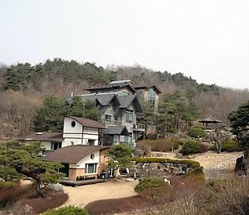

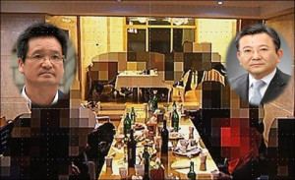

14. A Japanese imperialist group that inherits the insane "kamikaze" spirit.

The reason Korea was able to maintain an independent language and culture in Asia and spread ancient, advanced civilization to Japan may have been because of its unique geographic location, which prevented it from being annexed by the huge country China.
There is a story that says that people in Asia who were chasing the mysteries of the world continued to move towards the rising sun and migrated, and that the place they stopped was the Korean Peninsula.
There is also a hypothesis that Japan was founded by cultural groups who migrated across the Straits in search of mysteries or who were defeated in power struggles on the Korean Peninsula.
While Japan was able to build an independent culture without interference from the great country of China, Japan suffered from constant civil strife and brutal wars for a long time.
As an island nation, Britain was free from the wars of the continent, and Christianity was able to spread, which gave the country some virtuous order. However, in Japan, where Buddhism and Confucianism, which were spread from Korea, were the entirety of spiritual civilization, a tremendous amount of superstition became a part of daily life.
Religion in Japan is so disorderly that the Unification Church, a cult religion in Korea, grew up in Japan not in Korea.

During the time when the Mongols were sweeping the world, the Mongols, who had swallowed up China and Korea already, attempted to complete their occupation of East Asia by taking over Japan, which had the mysterious country name of "the land of the rising sun" 日本 across the sea. When Korea, which was under Mongol rule, and the Mongol army allied to invade Japan, a "sudden storm" struck and caused great damage.
Many ships of the Mongolian Korean allied forces were damaged, and the occupation of Japan was a failure.
The Japanese believed that Japan was protected by a wind sent by the gods, and there are even many religious ceremonies to commemorate this event, so in Japan, where superstitions abound, it is absolutely considered to be protection by the gods. (The Chinese character 神風 "divine wind" is pronounced "KAMIKAZE" in Japanese. )

There have been quite a few political conspiracies and terrorist attacks committed by Japanese nationalist forces in alliance with pro-Japanese forces in Korea for a long time, believing that Japan's peace and prosperity can only be preserved by opposing peace and cooperation between South and North Korea.
In "The Art of War," 孫子兵法 a book by the ancient Chinese strategist Sun Tzu, there is a passage that says that "the best strategy is to win without fighting."

If the background of South and North Korea, which had been continuing peaceful dialogue and meetings, being destroyed by pro-Japanese forces who collaborated with Japan to elect presidents who would destroy inter-Korean cooperation and the current situation where war could break out at any time is the work of Japan and pro-Japanese forces, then this is a "Great Success of the Nippon club." (Japan and the alliance of pro-Japanese forces) Japan enjoyed significant advantages during the three-year Korean War that began in 1950 and ended in 1953,
enabling it to join the ranks of advanced countries.
Trump is hoping to sow discord between South Korea and North Korea and destroy both countries for the benefit of the United States.
The Chosun daily news and Dong-A daily news, the two largest media outlets in Korea (both of which have their own newspapers and TV stations), were vicious media outlets that bowed and chanted “Long Live His Majesty the Emperor” during the Japanese occupation.
The reason why Korea was unable to carry out a trial like France did, which executed 10,000 pro-Nazis, was because when the Republic of Korea was founded, the forces that could run the government were almost all pro-Japanese intellectuals, and most Koreans did not have a strong sense of anger toward forces that collaborated with the invading nation like France.

Even after Japan surrendered in World War II, forces that sought to preserve Japan's militaristic imperialist spirit emerged here and there, forming the background for Japan's political and economic circles.
Their leaders who lost the war insisted on carrying on the spirit of the KAMIKAZE (神風 "divine wind,") in which pilots committed suicide by boarding their planes and attacking American battleships.
One of the most representative among them was Sasakawa Ryoichi, who established the Nippon Foundation. Sasakawa Ryoichi was a man who admired Mussolini and was a Class 1 war criminal after World War II but was not indicted. He founded 日本財団 the Nippon Foundation in 1962, and his son is the current chairman.

Sasakawa guaranteed that there is nothing Japan cannot do if it continues the kamikaze spirit, and there are so many mad ones around the world who are crazy about blind nationalism like him, including rascal Trump.
Sasakawa Ryoichi made a fortune in drugs in China and was the president of a gambling business association.
His son, who is now the president of the gambling association, has taken over much of what he did. After the war, Japan tried to improve its external image by doing a lot of overseas PR work through organizations like the Nippon Foundation and fostering PR soldiers.
Harvard's Mark Ramseyer, who received supports from Japanese government and organizations, is one of them.

This securities fraud, which occurred in 1999, occurred during the time of Samsung's former chairman, the late Lee Gun-hee, who was suspected of having a Japanese mother and Japanese friends, possibly including Nippon Club.
Nomura Securities, which appears in the case, is one of the powerful sponsors of the Nippon Foundation established by Sasakawa, and among his nephews, there is one who has considerable talent in stock investment, and Sasakawa has been deeply involved in his securities investments.
If the Nippon Foundation invested a lot of money in Korea to foster pro-Japanese forces and create the Nippon Club, it is highly likely that it cooperated with the operations of a conglomerate securities company like Samsung, whose chairman is suspected of having a Japanese mother, so much more friendly with Japan than north Korea.

On July 9, 1999, the highest day for the composite stock price, each securities company's bulletin board had a news article saying, "Nomura securities in Japan set the year-end target price for Samsung CRT (now Samsung SDI), which was at a high of 78,000 won at the time, at a whopping 129,000 won."
A huge number of purchases were accumulated, and the highest price of the year is soon formed. At this time, the highest price of Samsung CRT for the year is 82,900 won, thanks to the purchases of many people. The very next day, large conglomerate securities firms, seeing that they could make a profit, all turned to selling in large quantities, causing the stock price to continue to fall, and the last stock price of Samsung CRT in 1999 fell to the miserable 40,000 won range.
This is judged to be an operation that is almost a perfect crime. First, since it is information from a foreign organization in a neighboring country, domestic investment institutions are not responsible for the source of the operation information. Nomura Securities can also avoid responsibility by saying that it is only an expected price.

However, regarding the stock price that is on a steep downward trend at the crossroads of moving from CRT to TFT (in fact, foreign investment institutions are selling off Samsung CRT on a large scale around this time), the securities company's breaking news that Japan's Nomura is selling its name and setting a target price that is a whopping 60% higher than the stock price at the time will require Japan's Nomura to fully explain the background of the suspicion of intentional criminality.
And, starting the day after the announcement, domestic investment institutions simultaneously sold off all their stocks as if they had made a promise. This was a large-scale fraud that defrauded many national investors during the stock market boom after the IMF crisis. So many Koreans fell for this kind of fraud, and there was even talk that "the middle class in Korea" had all fallen for this type of securities fraud.
In still developing countries like Korea, the response to securities crimes is very weak compared to advanced countries like the United States, and even the judiciary often turns a blind eye when powerful groups like conglomerates collude. So, should we be telling people not to be born in a country like Korea?
Nomura Securities is a supporting member of the Nippon Foundation, and Sasakawa Ryoichi is very familiar with crimes such as securities operations, as he is deeply involved in the affairs of his nephew, who is very skilled in securities investment.
The Nippon Foundation claims to advocate world peace on the surface, but do you, Chinese scholars, believe the world peace claims of a businessman who made a fortune in drugs in China, or do you find them ridiculous excuses for a conspiracy?

Sasakawa Ryoichi and the Nippon Foundation, and their religious Kamikaze.

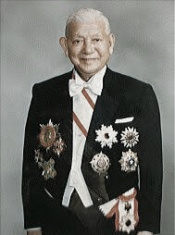

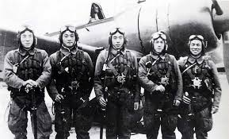
15. “Street Opportunism," but a virtue of the national heroes in tiny nations in the Near East.

Theologians have wondered what had made the scripture writers write "the tale of Jacob," whose name had been changed to "Israel," and become "the father of the twelve tribes of Israel" in the Genesis.
A good many theologians agree that they had made up this story in order to justify the kingship of two country builders, David and Solomon, who built up the nation but not the first sons, which was against the strong tradition of in the Near East that only the first sons take over the ruling of the family.

Jacob is born as the second, but he is grasping to be the first from the earliest moments of his life. They name him Jacob (yaʿaqōb), which means, "he grasps the heel," or figuratively, "he deceives," "a supplanter."
Jacob tricked his brother, Esau, out of his birthright. After an encounter with God, Jacob’s name was changed to Israel, which means: The Prince of God.

The tale of Jacob not only justifies the kingship of unqualified national heros, but also defines the requirement characteristics of "the Prince of God" at later time who has to be "the skillful suppanter" in Israel like tiny nation.
The new name ישראל “Israel” is a combination of the verb ש.ר.ה, “to strive with,” and a designation for God, אל.
The passage uniquely describes a person successfully battling God or his messenger, a suitable folk etymology for the origin of Israel’s name, which effects the people of a tiny nations in which the opportunism beats the others.

It is never possible for tiny Israel to wrestle with their bullying neighbors and survive (Egypt, Assyria, and Babylon) physically.
The people of small nations might have believed that this kind of technical deception as "the feat and virtue," the most efficient way of success, as long as this kind of craftsmanship provides them with their national safety and the wealth.

"Jehovah" was cast as "the national chaplain," whose main job is to declare the first inauguration of the kingdom of David and Solomon, the former was a mean bandit mercenary of opponent of Israel, Philistines, and the latter is his shameful son who is an dishonorable offspring between David and the wife of his faithful subordinate whom was driven to the death.

Jacob, "a master model of deception" and the standard hero of the nation of Israel, and his descendants of holy nation builders, David and Solomon, as the virtue and justice of the ruling elites of the nation had formed "the shortcut format of success" of the selected people of God of Judaism and the conservative Christianity.
It really is the core popular concept of the ruling elites in the western world, attractive and powerful enough to paralyze the plain sober power of reason and the conscience of a good majority of mankind for two full millennia.
Quite many bad guys have tried to copy the characteristics of two iconic holy nation builders, David and Solomon.
They could do anything bad, sly, violent and filthy, but could be forgiven by Jehovah at the end and enter the kingdom of heaven, which really is the most wonderful religious attraction andy clues why Judaism and the Christianity have been prosperous.

The clue of success varies from nation to nation.
If you want to win the Presidential election in the United States, you must first swear allegiance at wailing wall in Jerusalem as a faithful proof of a total surrender to Israel and their almighty paper God, Jehovah.
Ancient Africa for instance, bravery of canivals could be counted as the required virtue and justice of the chieftains.
The same kind of required courses and the qualification personality of virtue and justice of Israelite rulers look like to fit to the characteristics of Israel, the youngest tiny nation in the Near East. This success story of deceptions and exceptional cases of Jacob, and David and Solomon has polluted the moral of the human society entirely as much as it is taken for granted that Christian and Jewish rulers and the following elites be free from the penalty of the guilty of the crimes in the moral of a good guy Jesus.

Jacob's tale encourages the bad guys that they could do anything bad when the complete with the successful ending, which really is the ethics of the survival of the fittest, and ruined the cosmic criteria of the judgments, reason and conscience, which is why the Judaism, Islam, and the conservative Christianity are the crime religions to be banished.
What an attraction of these silly and holy religion, Judaism and conservative Christianity are, which embrace all kinds of dirty and filthy desires and massacre can do everything and be forgiven by their man-made paper God Jehovah anytime anywhere.
They got even sympathy for whom are not covered by the random order of the grace of their almighty Jehovah.

Mankind has been pushed up to believe and memorize these holy scriptures and make up "the perfect holy theology" from these cheap street tales and Arabian Nights like fun fictions, and their silly holy allegories have ruled over them for two full millennia with an initial icon of "Jesus" of attraction of eternal life, whom really has nothing to do with Jehovah and Judaism.
Moreover, Jewish supreme court is going to be back to the period of the inquisition in European middle Dark ages.

I have no mind to humiliate the Judaism which could maintain their wonderful language and tradition with the help of their national pride of mother religion of the child Christianity, however, it is a matter of common sense to give up harmful misunderstanding of God and awful progress of self-illusions and violent arrogance.
Rebekah’s plan to secure the patriarchal blessing for Jacob in Genesis 27:5–13
23 Jehovah said to her, “Two nations are in your womb, and two peoples from within you will be separated; one people will be stronger than the other, and the older will serve the younger.” (Genesis 25:23) 25 The first to come out was red, and his whole body was like a hairy garment; so they named him Esau.
26 After this, his brother came out, with his hand grasping Esau’s heel; so he was named Jacob. (Genesis 25:25,26)
Genesis 32:28 Said the other, “What is your name?” He replied, “Jacob.” 32:29 Said he, “Your name shall no longer be Jacob, but Israel, for you have striven with beings divine and human, and have prevailed.”
Genesis 35:9 God appeared again to Jacob on his arrival from Paddan-aram, and He blessed him. 35:10 God said to him, “You whose name is Jacob, you shall be called Jacob no more, but Israel shall be your name.” Thus, He named him Israel.
We could say that the success of technical deception of the opportunists has been admired as "a feat of Justice" which guarantees the wealth and the safety of their patriarchs.
The fairness of the match, or moralistic honesty do not seem to matter in ancient time when the survival of "the group" comes first all the time among all other things.
The virtue and the feat of the clever opportunism

The clue of personal success varies from country to country.


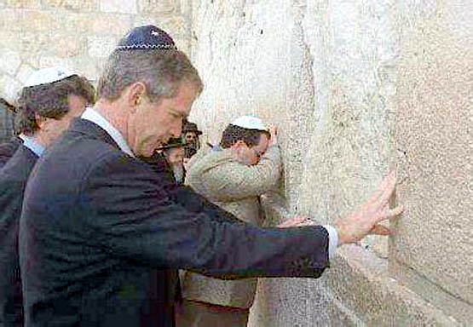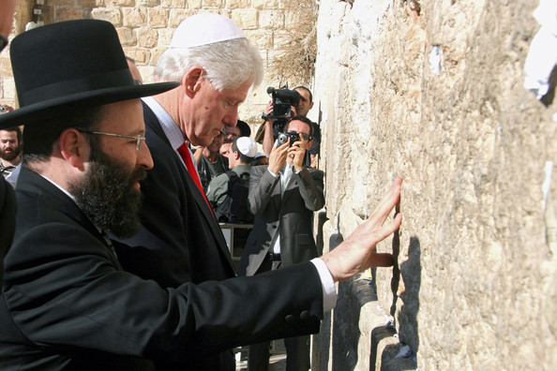
16. True Christian knowledge and wisdom can cure "everything" in the world.
(Who can practice "Love your enemy," an absurd Bible verse?)

Norman Gottwald, the author of "The Tribes of Yahweh (Jehovah)," is a confident scholar who was quite certain about historical and literary background of where and what parts of the Hebrew Bible were created.
GE Wright and FM Cross are scholars who have accurately clarified the historical background of the process of manipulation of the Hebrew Bible based on archaeological evidence and philology in the Near East.

It is quite natural that legal scholars who study the perfect judgment of cases would wonder about the ultimate concept of "sin and evil in the kingdom of God." The courage that enabled Thomas More, the author of "Utopia," to protest the absolute power of the king, John Locke who founded the separation of powers, and Rousseau, the theorist of the French Revolution, to stand up against the power of evil, was courage given by God.
Just as Western civilization was properly founded on the truth of Christianity, the only way to overcome the current disastrous disorder and violence is for humanity to arm ourselves with "correct understanding of the sole God Jesus."

In the 39 books of the Old Testament and the 27 books of the New Testament whose contents are so poorly polluted, the image of Christ is the only image of God in real human history who could walk the line between life and death.
If humanity erases the illusion of Christ that has been polluted by the superstitious group of Israel, and finds the correct image of the Christ, a true community with the almighty God will become possible.
We humans can return to the time when Christianity established the order of Western civilization and God was alive.

The Gospel of Matthew, which begins with a bizarre Jewish genealogy that resembles a beef steak with three pizza toppings, depicts Jesus as a person who discriminates foreigners.
https://suban.com/instructiontodisciples.htm
Matthew, to dispel Jewish animosity, argues that Jesus' existence is not against Judaism against them, but rather the continuation and completion of Judaism.
https://suban.com/law.htm
Matthew is busy manipulating the image of Jesus, making his own anxious claims that are neither here nor there. https://suban.com/sword.htm

What is an irony is that one of the most famous verses representing Christianity, “Love your enemy,” does not appear in the original Gospel of Mark, but only in the Jewish Gospel of Matthew and Luke copied, which raises the possibility that this famous verse was deliberately inserted by Matthew. https://suban.com/loveenemy.htm
Could the enemy mentioned here be a tax collector who collects taxes from Jews for the enemy country that the Jews hate? Could this therefore be an implicit recommendation to embrace Matthew, whose profession is a tax collector, rather than hate him?

Greek word "enemy" ἐχθροὺς [echthrous] is someone you are hostile with emotionally not Gentiles like whom you should not get along with, the enemy of the Jews. This verse means to subdue your personal anger, which is guessed something like a well-minded local guru's teaching pharisee alike for the unity of the Jewish community.
If it had been written to love the "gentile" rather than a personal "enemy," the author Matthew would have been stoned to death, and the Gospel of Matthew could not have survived.

Personally, “Love your enemy” was one of the most difficult verses in the Bible to understand, not only because it is absolutely “impossible” to put into practice, but also it is not a good remedy in my personal opinion.
Is it possible for us to easily forgive the criminals who have harmed us and our families? If it were easy to do so, the world would become even more wicked and run wild. Is the reason the Pope doesn't go to Ukraine or Gaza to stop the war because he has to love the evildoers who keep killing? www.PopeinUkraine.com

Christian theologians and clergy have had to resort to many bizarre allegorical interpretations for two thousand years after Jesus' execution to practice this kind of passage in the New Testament Gospel of Matthew, which, like Jewish scriptures were exclusive to Gentiles. Because they kept repeating the same absurd actions without finding the answer, countless contradictions, hypocrisies, and evil deeds have piled up in Christian civilization, and as a result, they have led to the history of evil of humans who have become estranged from the justice of "God."

The Bible is a series of bizarre cases shrouded in mystery, but it also poses a fascinating challenge to the able detectives who want to solve difficult cases even though it takes almost a lifetime.
Moreover, the fact that the Gospel of Matthew, which fabricates a Jesus who discriminates Gentiles, is placed at the very beginning of the Christian New Testament has strongly instilled in Jewish fanatics like Netanyahu the perception that Gentiles are puppies that eat the crumbs left over from the Jews' meal. https://suban.com/nonjewishgirl.htm

This kind of intentional and malicious redaction of the Bible has given rise to misunderstandings no different from the American Constitution stating that colored people must be subject to white people in religion.
While the Bible, which has been exaggerated and manipulated like this, has dominated Western civilization for 2,000 years, Christianity has committed heartbreaking crimes such as “imperialism” and “racism” in human society.

Western Christian countries have committed indelible crimes against Africa, and Asian countries such as China and India driven by even more extreme hatred and greed than the current Netanyahu like Jewish fanatics.

The hypocrisy and limitations of Christianity, which justified all greed and easily freed one from the pangs of conscience by simply wearing a cross and calling Jesus Lord, were no longer an object of reliance as the Western world entered an era of material abundance.
The cruel illusion of Christianity is capitalism, which justifies the cruelty of the “winner takes it all,” and the "survival of the fittest" system through the vested interests of the haves and the malicious customs of humanity, "nationalism."
Even though mankind has developed scientific civilization, it is exhausted in war and excessive competition to kill each other. True teaching of Christ is "abandonment of nationalism," unity and eternal peace for all mankind in the world.
Even Paul, who had never met Jesus in the flesh, opposed discrimination against Gentiles because he received Jesus' teachings through direct spiritual communication with Him.

If someone passes by without helping you when you are completely drained of energy and collapse on the street, you will call them a "bad guy." Due to internet commerce and excessive competition for survival between countries individuals, quite many jobs have disappeared, and in Korea, sometimes high school teachers can be hired by paying huge bribes. This is a common disaster that all of humanity is experiencing, although with some differences.
A law that is not able to restrain evil is nothing more than a note written on a piece of paper.

The only God Jesus taught, "The sabbath (law & rule) was made for mankind, and not humans for the sabbath (law & rule)."
又对他们说，安息日是为人设立的，人不是为安息日设立的 (Mark 2:27), but the world has become so devastated that it is impossible to find anyone who pursues true happiness and ideal order for the human soul, the master of life.
For the sake of our children's generation and the eternal peace of our families, we must establish a world order for the right order of human society and the masters of life, not for devils like Max Weber or Netanyahu.

Netanyahu, Putin, Xi Jinping, Kim Jong-un, the Myanmar warlords, and Trump are nothing more than evil thugs that humanity must subdue, yet humanity is just watching the catastrophic violence of just a few evildoers.
Just as you would call those around you villains if no one around you step forward when you are being assaulted by a thug, I would call you villains if you turn a blind eye to the evil deeds of Netanyahu, Putin, Kim Jong-un, Xi Jinping, the Myanmar warlord, and Trump. It is humanity's natural duty to subdue evildoers by calling them "thugs."

It is not because mankind does not have sufficient judgment of right and wrong, so they turn a blind eye to these thugs, but rather that the disorder and pollution of modern society have piled up so much that no one, rather than cleaning it up, is vulgarly opportunistic and clings to their own right to survive amidst this disorder and pollution.
Do you think God turns a blind eye to the hearts and violence of evildoers when it is possible even for humans to observe and record every action and movement of all human beings in the world using our limited technology?

I think that the life we live is a test paper that records our trials and errors and the judgments before going to the afterlife, and it is not a devil's murder play that justifies the crazy fanaticism and violence of the "selected people of God" instigated by the wrong religions created by humans.
The cause of human disaster is that mankind has lost its conscience and courage, the noble judgment of the human soul, while being unable to escape from the shadow of the illusion that mankind has created.

Those who were born with silver spoons on their mouths and grew up with overprotective parents have a hard time experiencing the truth of the world. I believe that God gave us such overwhelming tasks as Ukraine and Israel so that we could train ourselves in true human courage and conscience. We would be scared if we met a knife-wielding robber in front of us, but almost all the robbers with such habits are now in prison.
I am not scared of calling Netanahu, Xi Jinping, Kim Jong-un, and Myanmar warlords “devils," because they committed crimes already far beyond what they deserved and were to be condemned to death.

You are writing a "test paper" to determine grade for the afterlife, and God is watching you!

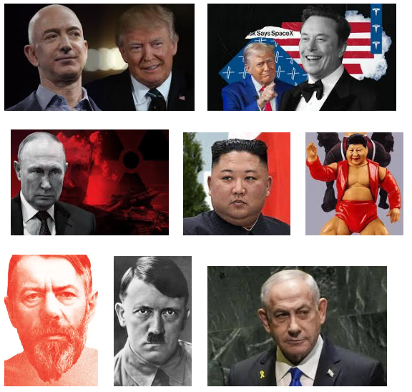
17. Was the female President having an affair when 300 teenagers drowned?

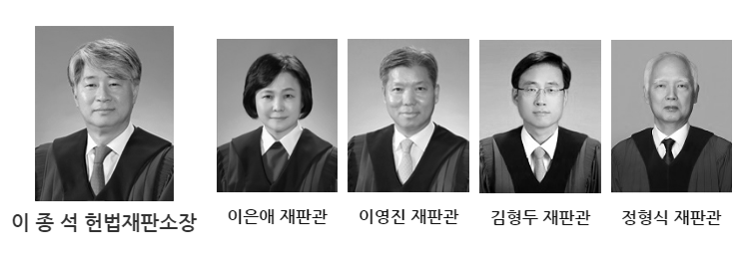
After the Sewol ferry sinking accident was published, on August 3, 2014, Tatsuya Kato, who was the Seoul bureau chief of the Sankei newspaper at the time, published an article entitled “President Park Geun-hye went missing on the day the ferry sank,” stating that President Park Geun-hye’s whereabouts were not known during the seven hours aboard the Sewol ferry. ... He published a column titled “Who did you meet ?
(朴槿恵大統領が旅客船沈没当日、行方不明に…誰と会っていた？).
The Sankei newspaper claimed that there were suspicions that President Park Geun-hye had an affair with Jeong Yun-hoe during the hours when Park Geun-hye's whereabouts were unknown after the Sewol ferry sinking, which was accused of defamation by nationalists.
As a reporter who considers it a crime not to report the facts, how did Kato obtain information about the affair ? Kato is currently a senior agent of the Japanese C.I.A. His job as a reporter fluent in Korean at the time of the sinking of the Sewol ferry was raised to disguise his identity, or he may have acquired information from the Japanese Intelligence Service as a reporter for a representative Japanese nationalist newspaper.
As Korea is Japan's fourth virtual enemy, it is very natural for Japanese intelligence to observe the past and live movements of the Korean president.
Park Geun-hye, who was single, created a very bizarre rumor of a possible affair with a con man pastor named Choi Tae-min after her mother was shot and killed.
For this reason, dictator Chun Doo-hwan, who succeeded to the presidency after the death of Park Geun-hye's father, Park Chung-hee, forcibly exiled Choi Tae-min to Gangwon-do in an attempt to force Park Geun-hye and Choi Tae-min apart when he was the security commander.
It is possible that this bad relationship was retaliation by Park Geun-hye, who later became president and demanded huge amount of criminal compensation from Chun Doo-hwan.
Since Jeong Yun-hoe was the husband of Choi Tae-min's daughter Choi Soon-sil at the time of the incident, the scandal between Jeong Yun-hoe and Park Geun-hye is a very bizarre incident that deserves to be recorded in history.
The possibility was even raised that Choi Soon-sil, who gained power around Park Geun-hye and played around with Korean politics in order to get Park Geun-hye to let go of her suitability for being unmarried, intentionally made her husband, Jeong Yun-hoe, meet Park Geun-hye.
Choi Soon-sil, who became close to Park Geun-hye after the death of her father, Choi Tae-min, and was even mentioned as Korea's highest power by playing with Korean politics, is sentenced to 20 years in prison after
Park Geun-hye was impeached for corruption.
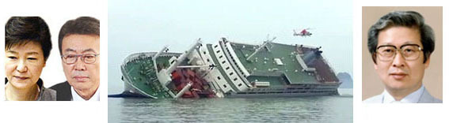
President Park and Jeong, and the ship owner whom is thought to have committed suicide Yoo Byong-Un.
Although there was sufficient time to rescue the Sewol ferry over a long period of time several hours, 300 people drowned to death due to the Korean government's inadequate response. The biggest reason was that the crisis management headquarters and manual created under President Roh Moo-hyun to prepare for such a crisis situation were discarded by the impostor President Lee Myung-bak, and the next was Park Geun-hye's loss of contact.
There is even a possibility that the Korean government hid the truth of the incident to prevent its country's shame from becoming known to the outside world.

On June 1, 2024, Korea's Constitutional Court declared the government not responsible for the incident in which 300 teenagers drowned to death after struggling for a considerable amount of time to rescue them and not even contact the president.
This ruling, led by Constitutional Court judges of the Law school of Seoul national university, is another repetition of Seoul national university’s tyranny.
The chief and the judges of the Korean Constitutional Court who ruled that the government was exempt from liability, four of them were graduates of the Law school of Seoul national university except for the one in the middle.
18. 159 people were senselessly crushed to death, and 195 were injured in Etaewon, Seoul.

The tragedy in which 159 people were senselessly trampled to death and 195 were injured including several foreigners on Halloween day in Etaewon began with extremely absurd corruption and superstition.
President Yoon Seok-yeol and the First Lady, who has been rumored to be a call girl, refuse to go to the Blue House where the President resides, and the reason is shocking and quite bizarre. Yoon Seok-yeol has a fortune teller who has been his mentor for many years and has 14 previous convictions.
The reason for this was that the fortune teller told him not to go to Blue House because he would get in trouble if he went there.
This crazy soothsayer, Cheongong 天空, claims that Jesus is a failed prophet because he was executed.

The Chinese characters for Blue House, 靑瓦臺, mean a house covered with blue tiles. When interpreting this metaphorically, 瓦 is interpreted to mean failure, so it is also interpreted to mean "to fail completely."
In fact, the first president Syngman Rhee was a dictator and fled to Hawaii where he died. Park Chung-hee's wife was shot to death and he was later shot to death. Chun Doo-hwan and Roh Tae-woo were sent to prison.

Roh Moo-hyun committed suicide by jumping off a cliff due to organized pressure from those around him.
Lee Myung-bak and Park Geun-hye were imprisoned for several years for corruption before being pardoned.
Moon Jae-in and his family are currently under investigation for various corruption charges.

One cause of the Etaewon disaster was that the president refused to stay at the Blue House, so the police in charge of Etaewon focused their security efforts on the president's residence in Yongsan, which was next door.
And the reason is that the police chief was chosen as someone who is good at flattering rather than someone who is well-versed in the job. The Seoul Metropolitan Police Agency chief is a person who lacks actual job expertise, and the absurd Etaewon security operation he carried out was the direct cause of the accident.

According to several media including "Newsweek" and "Time," on Halloween, when over
100,000 people gathered in Etaewon, only about a dozen police officers were seen.
Compared to the past when over a hundred police officers were responsible for security,
the core of this incident was the very bizarre and absurd idea of making a small number of
police officers visible to enable drug dealing at the scene and arrest all drug dealing criminals
during this opportunity. For this absurd operation, police called in 58 police officers
from around the country, all in plain clothes rather than uniforms, to try to catch drug dealers among the crowd.
Here, I am denouncing to the world one very evil villain who played a decisive role in making Yoon Seok-yeol the president. His name is Ahn Cheol-soo, a former doctor and now a member of the National Assembly.
Ahn Cheol-soo made extreme criticisms of his presidential primary opponent, Yoon Seok-yeol, saying, "If we vote for Yoon, the people will end up with a miserable result where we will want to cut off our own fingers."
Ahn Cheol-soo, who had criticized Yoon so harshly, turned to supporting Yoon right before the election and became the first person to initiate an incident that resulted in massive national casualties, i.e., Etaewon disaster.

In a country like Korea where there are reports of illicit collusion to win elections, many Koreans suspect ruthless collusion or dealings between Ahn and President Yoon for the purpose of vested interests.
In the small country of Korea, the number of National Assembly members increased to 300 for their own vested interests, and each National Assembly member has 8 personal secretaries and even a chauffeur, paid for with taxpayers' money. The reason there are so many opportunistic thugs and fraudsters is because most of the politicians who control their nominations are extremely corrupt and thugs who are good at lying.

Many of the things Ahn Cheol-soo boasted and promised before the presidential election were later revealed to be lies, and the enormous cost of campaigning based on those lies was paid with taxpayers' money.
But the most serious problem is that even the evil Ahn Cheol-soo is average among Korean politicians in terms of his lies and hypocrisy, and many other politicians are worse than Ahn Cheol-soo.
The stock of Ahn Cheol-soo's computer vaccine company, which the Korean people supported by promising to protect the domestic virus vaccine, skyrocketed due to expectations that he might become president, but Ahn Cheol-soo sold all of his stocks at the highest price and bought them back when the stocks plummeted again, causing damage to many Korean investors and earning him the nickname "high-level fraudster."

The damage caused by evil people in the political world is so severe that the number of elderly people and citizens who commit suicide due to the pain of survival caused by the murderous gap between the rich and the poor is at a world-class level, and the entire society is so corrupted by corruption and disorder that it is difficult to see a proper leader.

Ahn Cheol-soo, a vicious villain who criticized Yoon Seok-yeol to the extreme, and then promoted his own best making Yoon Seok-yeol president.



Kim Mi-kyung, Ahn's wife, who has been accused of being an unfairly hired professor, received the lowest score in the Seoul Medical professor evaluation for six consecutive years.

The reason why Ahn Cheol-sae's nickname is "Migratory Bird" is because he has been deceiving
the people by changing his opponents for his own convenience and benefit.



If you look at this website, you can see the miserable hellish situation at that time and the wickedness of the political villains who created it. www.Etaewon.net

19. "Balance of body" is the key to the seniors' health.

When the left-right balance of the body begins to break down, this continues to worsen until the human body suddenly collapses to one side like the Leaning Tower of Pisa, losing its balance and making it diffict to exercise and live, and eventually becoming a frail old person who can no longer move.
Even if the balance of the left and right bodies starts to break down like this, we don't know how to deal with it, and we just ignore it and dismiss it as a natural phenomenon of aging in the elderly.
In order to prevent the loss of left-right balance, which is one of the most important issues in senior health, you should do stretching for the areas that are lacking and strengthening exercises such as yoga that can evenly distribute energy and blood. I sit my wife down every day and pull her arms back and push her spine with my feet. This is one great way to balance her upper body and keep her body in balance through stretching.
In addition to the suffering that Koreans endure by being surrounded by extremely evil and corrupt politicians, former President Moon Jae-in pardoned an evil conman criminal when he was the Chief of Staff to the President, and after becoming President, he spent tax money for over a year to make a conman Lee Ki-heung an IOC member.
In exchange for pardoning Lee, a criminal who embezzled a huge sum of money, a bribery charge is raised.
Lee served as the President of the Korea Sports Association, which dominates the Korean sports world for 9 years, turning the sports world into a black world dominated by many bad-tempered bad guys.
The Korean sports world is so rotten that many executives of the sports organization, of which Lee Ki-heung was the chairman, were arrested and imprisoned for gambling at casinos with the association's money.
Sports organizations are being reported to have been dominated by swindlers for nine years, regardless of the health of the people, and many elderly people have lost their ability to be economically independent, suffering from the lack of popular sports and entertainment facilities, and have even committed suicide by jumping from apartments. Lee was recently reported to have been involved in corruption by appointing his brother-in-law as a high-ranking official of the Sports Council and spending money lavishly.

The current global disaster is so extreme that many elderly people live on the edge of death, unable to engage in economic activities or perform physical activities necessary for their basic survival, despite the extension of the average human lifespan. If we do not protect the weak and show an attitude of cooperation and coexistence, the majority of elderly people around the world will inevitably fall off the cliff as powerless weak and poor people.
To solve this worldwide desperate poverty of the elderly, I am planning a senior living community farm where the elderly can live independently and survive with reasonable labor and low cost.
More than 16 years ago, I had a surgery to remove part of my nasal cartilage from Dr. Dong Heon-jong, the former head of the ENT department at Samsung Hospital, to relieve my nasal congestion. However, because a little too much part was removed, I suffered from waking up from sleep and seriously having trouble breathing.
Dr. Dong advised me to wear a mask while sleeping because I am so sensitive, and since the surgery, I have worn the mask every single day for 16 years, even while sleeping, and I have worn it for 16 years, even in the hottest summers, so there are people in my neighborhood who I know as tuberculosis patients.
Since then, I have come to know of the suffering of many patients who are suffering from severe aftereffects due to sinusitis surgery or cartilage resection surgery. One young patient repeatedly complained of pain to the doctor who performed the surgery, but the doctor treated him as a mentally ill person and prescribed psychiatric medication.
I learned the horrifying news through MBN news.
This was the content of their complaint as they formed a group. The reason why ENT doctors unilaterally ignore the pain of patients undergoing sinusitis surgery and cartilage resection surgery is ;
1. If this is recognized as medical malpractice, they will be held responsible for their own negligence and suffer disadvantages. 2. They cannot empathize with the pain that patients feel while breathing 24 hours a day because they have not experienced themselves. 3. They have no good way to relieve the pain of these patients after surgery.
4, Even if ENT doctors know about it, paying attention to alleviating side effects is not only a hassle but also not profitable.
After the surgery, my left nostril, where a part of cartilage was removed, became wider and was about twice as wide as my right nostril, so I went to Dr. Dong, complaining of not only difficulty breathing but also heavy imbalance of the body. He made the strange excuse that he had the surgery done because I insisted on it, even though I didn't even know there was such a surgery to widen the nostrils to improve breathing.
There are also Oriental medicine doctors who have witnessed many victims who have suffered damage and pain due to nose surgery, and they claim that the structure of the nose is naturally formed into the most ideal shape for each individual throughout life, and therefore, surgery on this ideally formed nose structure can be fatal to the respiratory structure and body balance, and therefore should never be performed.

I could improve the condition by having surgery to insert a prosthesis into the nostrils that had been widened by removing cartilage and had become even wider due to the deterioration of the balance years ago.
At the time, I was told that adding a prosthesis could cause the sutured part to come undone later, so I suggested that we start with a small size. Dr. Dong agreed, and my condition improved after the surgery. However, after a few years, I suffered from an imbalance in the left and right sides of not only my nose but also the whole body, so I went to see him a few years ago and asked him to add a larger prosthesis, but he refused.
There are many patients in Korea and around the world who suffer from side effects due to surgery to partially remove nasal cartilage or sinusitis surgery, but because the pain they suffer cannot be objectively proven, there are many cases where they suffer from the pain and die early, including committing suicide.
When the balance between the left and right sides of the nose is broken, not only is nasal breathing difficult, but the surrounding blood vessel pressure that creates the appropriate pressure in the nose is also lacking, which reduces blood circulation in one part of the brain, and the brain imbalance created here leads to imbalance in the entire body, which rapidly deteriorates a person's life and even turns them into a disabled person, causing early death.
Due to the imbalance in blood circulation on both sides, even young people have difficulty maintaining their body's balance, and if there is a problem with blood circulation on one side of the brain, vision in one eye may deteriorate significantly, or the imbalance in blood circulation may cause premature death due to brain diseases such as dementia.
To prevent the imbalance of my nose from destroying my entire body's balance, I have been doing an exercise for the past 16 years. It involves kneeling, holding dumbbells, and exercising both arms for nearly an hour to maintain my body's balance and directly helping blood circulation to the brain by exercising the muscles in my arms.
It has been medically proven that a significant portion of the blood vessels in both hands are directly related to the cerebral blood vessels, so exercising both hands is effective in improving cerebral blood circulation and dementia.
In addition, to improve blood circulation in the nasal blood vessels, which are gradually decreasing due to a stuffy nose, I insert several long cotton swabs, twice the length of a regular cotton swab, into my nose and rub them with my hand to prevent the nasal blood vessels from stopping functioning and blocking the surrounding blood vessels.
I have had the habit of wearing a mask and putting a few cotton swabs in my nose while I sleep at night to prevent my left nostril and brain from collapsing, and this has continued for over ten years.
If I hadn't spent over 10 years trying to improve my symptoms of difficulty breathing due to my empty nose and the surrounding blood vessels not functioning and becoming blocked, which caused my entire body to lose its balance, I think I would be dead or a wreck by now.
It is thought that there are a huge number of patients around the world who, when they appeal to ENT doctors, are laughed at because they have not experienced it themselves, and who are not legally protected because they cannot objectively determine the damage caused by such medical mistakes.
While there are patients who "suffer 24 hours hard" a day due to nasal imbalance that requires them to breathe 24 hours a day, there are also people who do not take the severe empty nose symptom caused by the imbalance in both nostrils seriously and "just live with it as a habit."
Otolaryngologists often excuse their responsibility by saying that patients do not complain of such great discomfort or are surprisingly accustomed to such symptoms, and unless there is clear legal evidence of a conspicuous empty nose, most of the time they shift all the pain and suffering to the patient.
I did not ask Dr. Dong for any compensation, and I paid all the costs of the surgery to remove the cartilage and re-insert the prosthesis. I also offered to pay for the surgery to relieve the pain in the future, but Dong refused.
Isn't the atrocity of ENT doctors, who make appointments and wait for months to receive treatment from the most famous ENT doctor in Korea and receive no response even after several public mail protests, violence that invites silent murder?
My email has been sent to thousands of theologians, law school professors, and humanities and social scientists from famous universities around the world for the past 10 years for the purpose of presenting my theological thesis.
It is also read by the International Judicial Association, foreign supreme courts, and prosecutors. Among you and your families, there must be many patients who are suffering from similar damage and dying in silence.
I have already informed many otolaryngologists of the seriousness of this problem by mail twice, including the director of the Seoul National University Hospital, Samsung Hospital, and Hana ENT Department, and that this is a serious problem for the health of many citizens, and I have also informed the Chief Justice of the Supreme Court, the Prosecutor General, members of the National Assembly, and media reporters, but I have not received any response from Dong Heon-jong himself, the most famous otolaryngologist in Korea.
In Korea, doctors collectively opposed the government's attempt to increase the number of medical school students due to the shortage of doctors, and as a result, people died in ambulances without receiving proper treatment due to the shortage of emergency room doctors. Shouldn't we view doctors who act out of collective selfishness as a "devil's group"?
Even in the capitalist country of the United States, where all citizens are groaning under the murderous medical costs, the medical association has been lobbying against increasing the number of medical school seats, thereby forcing the citizens to shoulder the murderous medical costs.

Traditional Korean song https://www.youtube.com/embed/9YJn0emEzPI

Doctor Dong, and Samsung Medical Center.



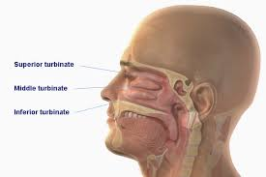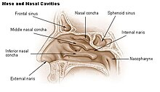

A bizarre candlelight vigil by doctors opposing increased medical school admissions.



Doctors denounce the increase in medical school admissions as socialism, but how dirty is this capitalist disease?

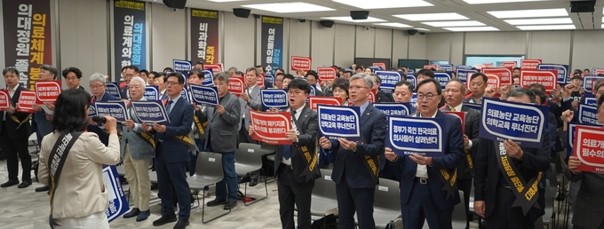

Lord, your mercy of peace,
not the wars of blood …!

Chaplain of the Lord’s church, Sang Wook Lee

